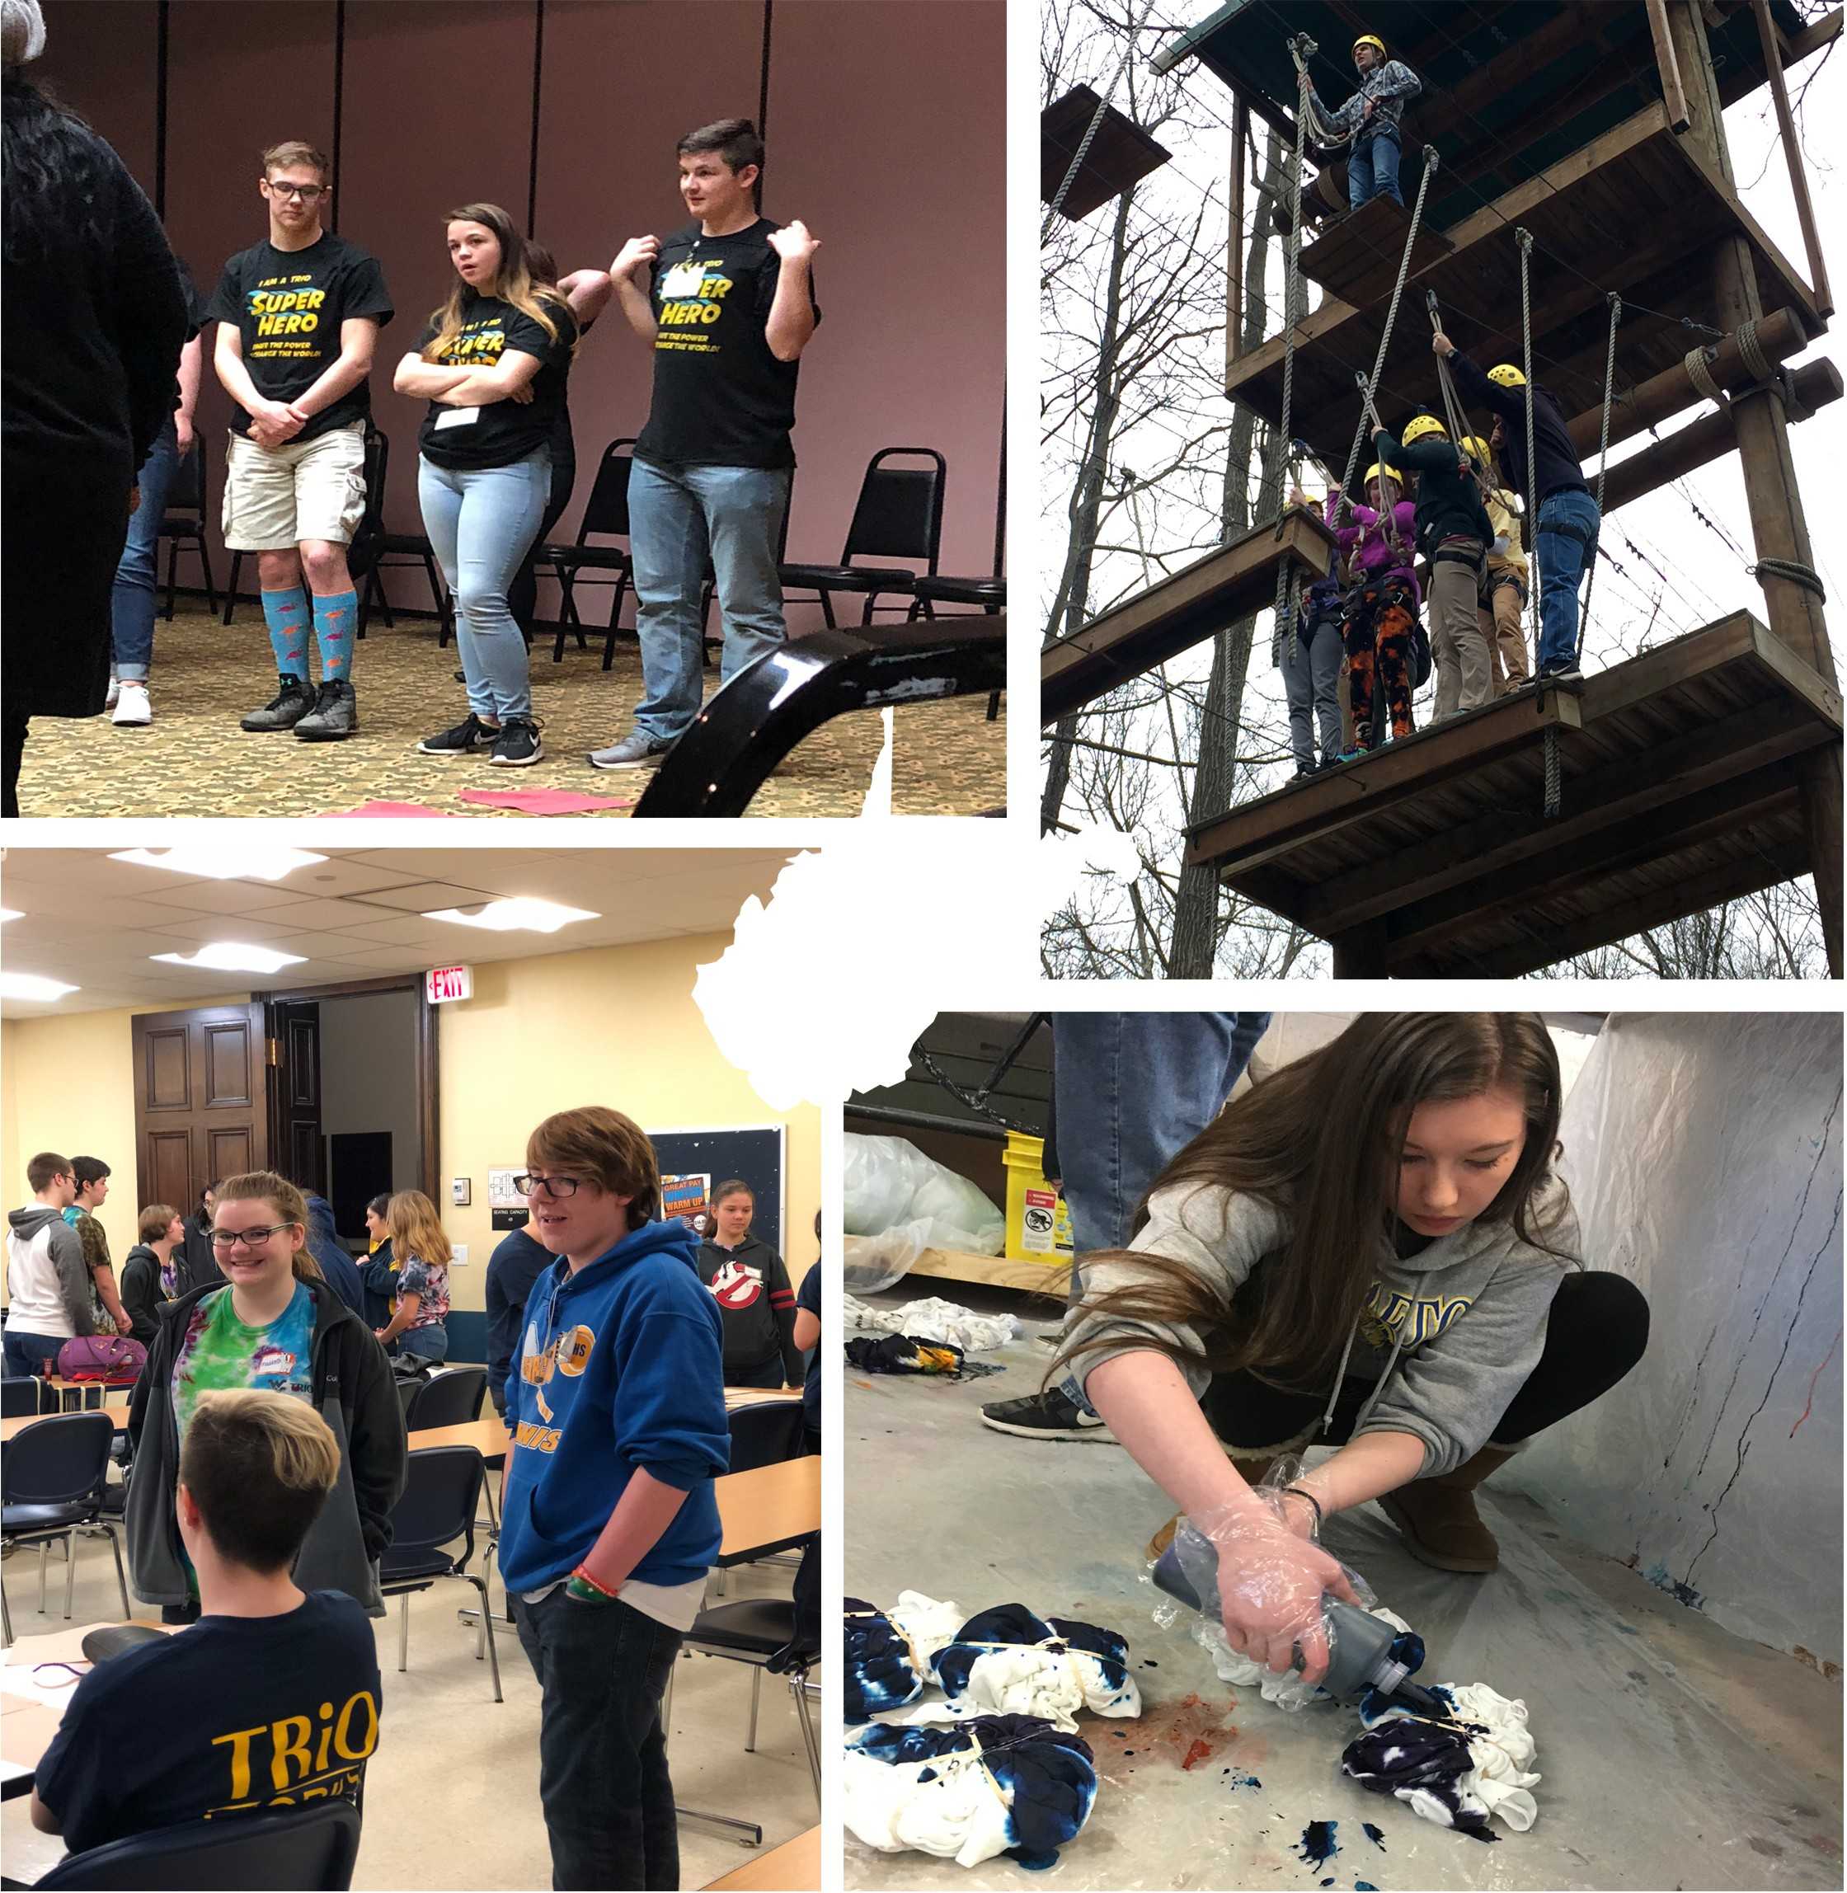

Spring 2018

WVU UPWARD BOUND UB TIMES

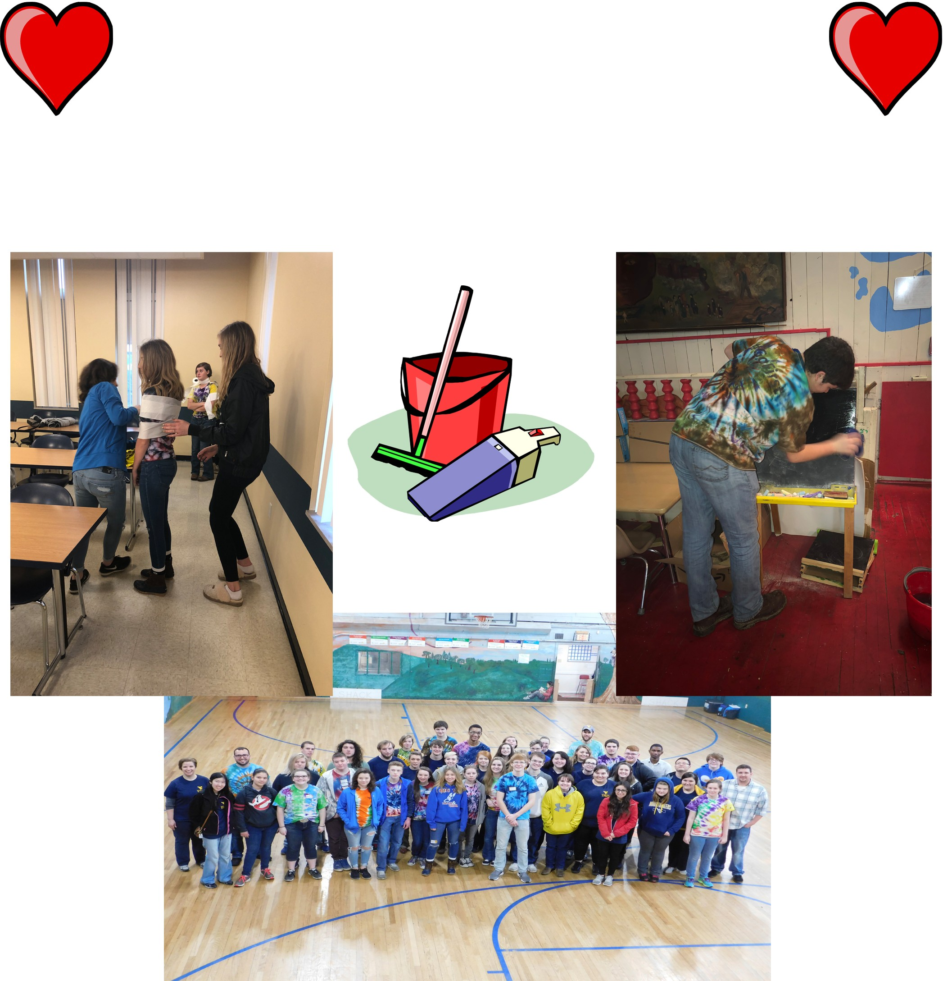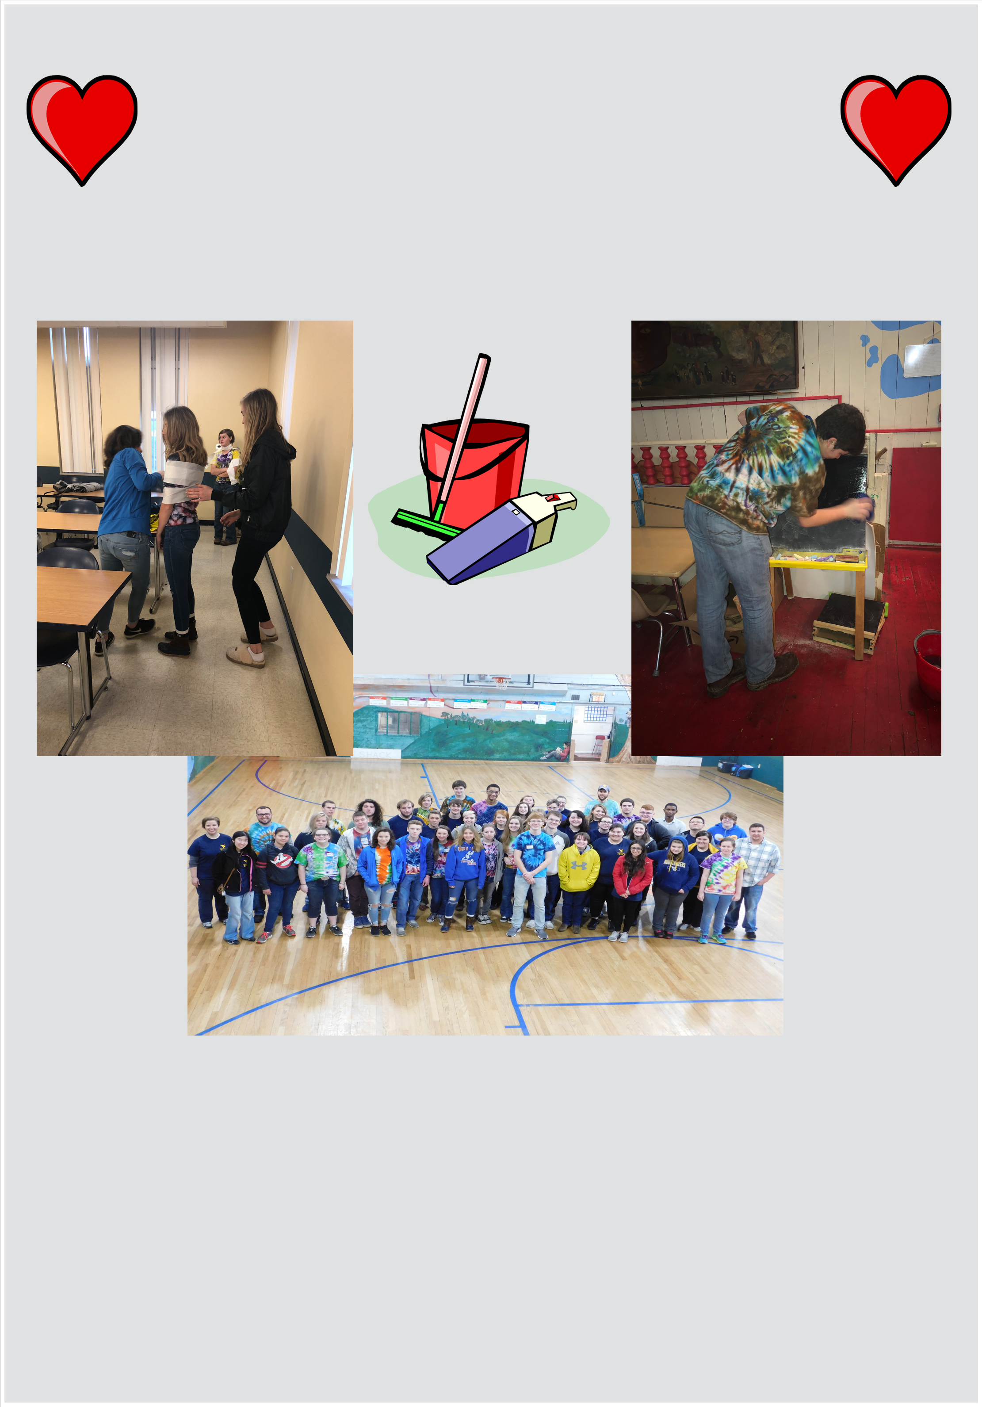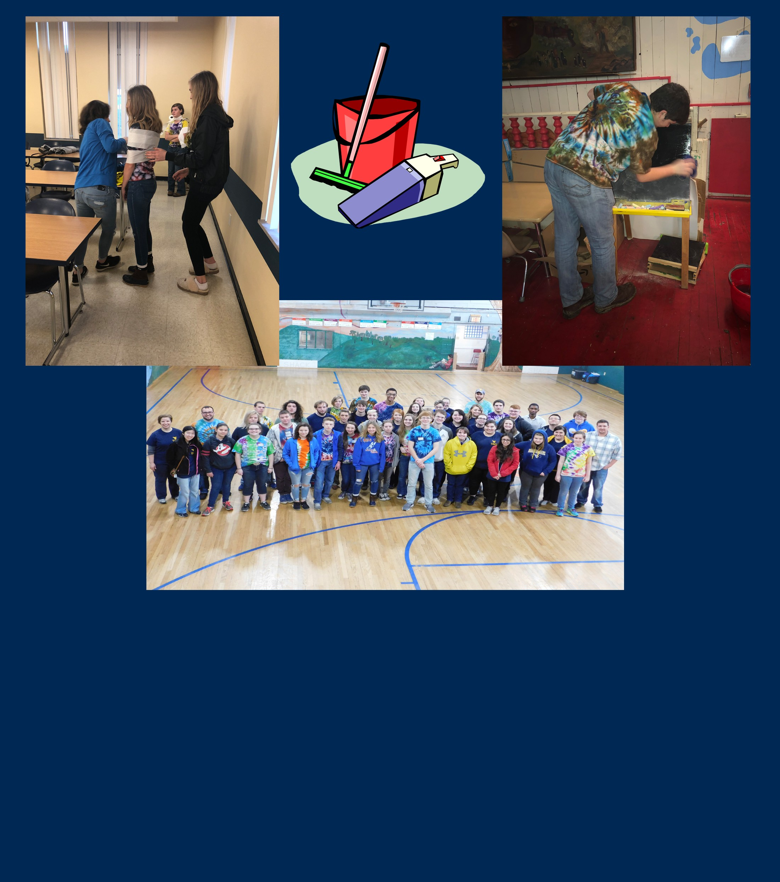FEBRUARY SATURDAY PROGRAM

On February 24, students got into teams and played Minute To Win It games to warm up for the day. Afterwards, McNair Scholar and Student Support Services students got together with UB students and participated in teambuilding exercises that consisted of creating the best flying paper airplane, building the tallest tower out of paper and tape, and making the longest paper chain. Then, SSS started oﬀ our celebration for National TRIO Day by giving a presentation of what TRIO is all about.
To end the day, all of the TRIO students went to a the Shack, a neighborhood house that holds diﬀerent activities for family, friends, and kids to have fun. There, the students did community service by helping with santizing the building and counting the ducks for their annual duck race.

Help With Scholarships

List of Scholarship Websites

chegg.com
- fastweb.com
  - raise.me
- scholarshippoints.com
  - cappex.com

Future Scholarship Tips
- Never skip out on the smaller awards.
- The scholarships with more work typically have fewer applicants which gives you a better
chance.
  - Check with your guidance counselor for any local scholarships.
  - Apply for as many scholarships as possible.

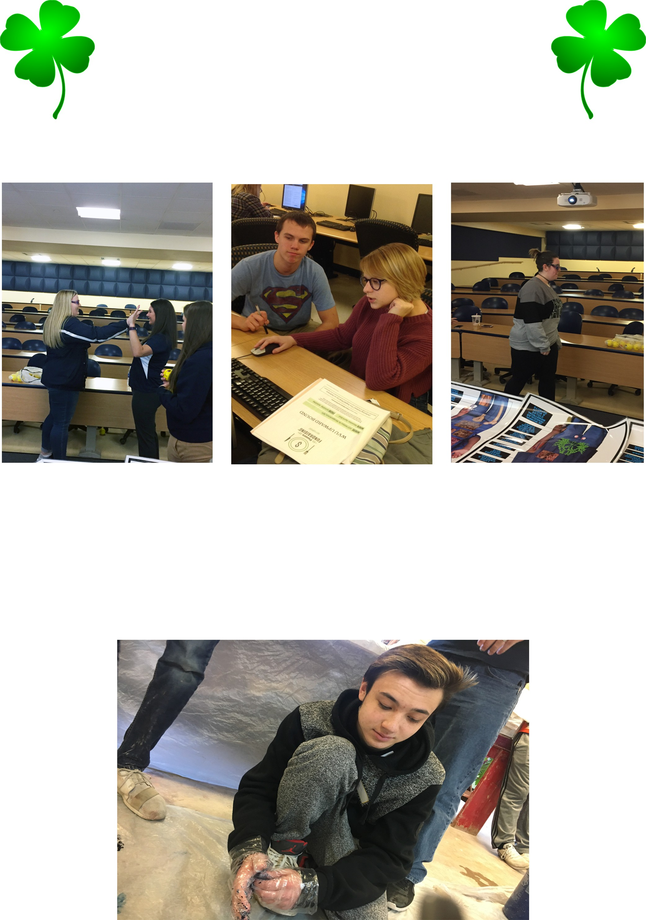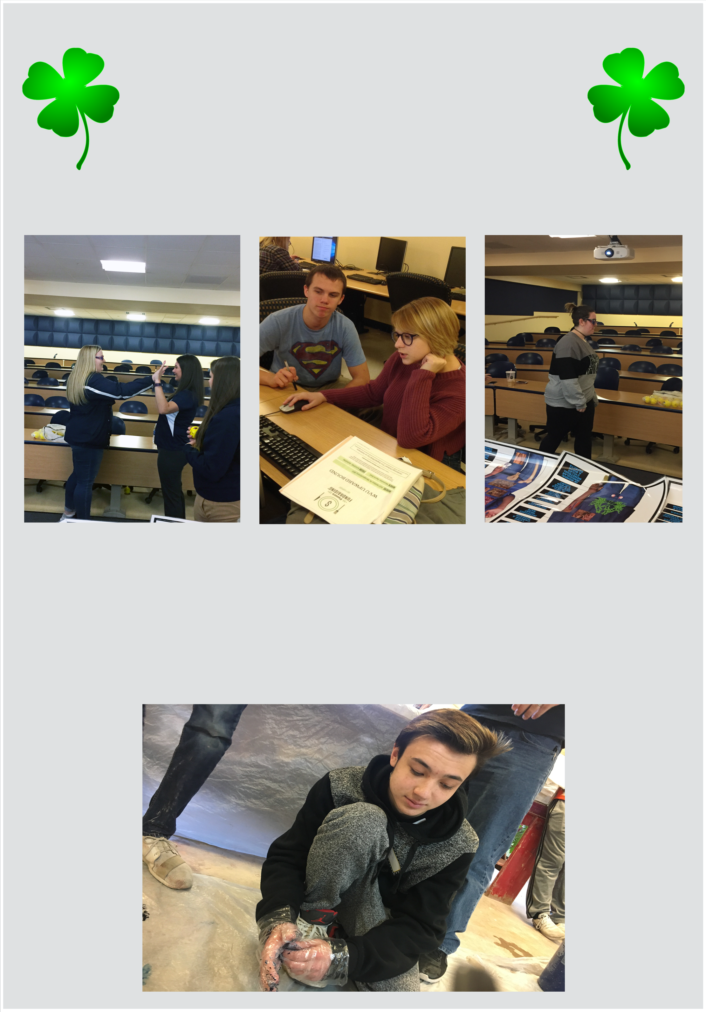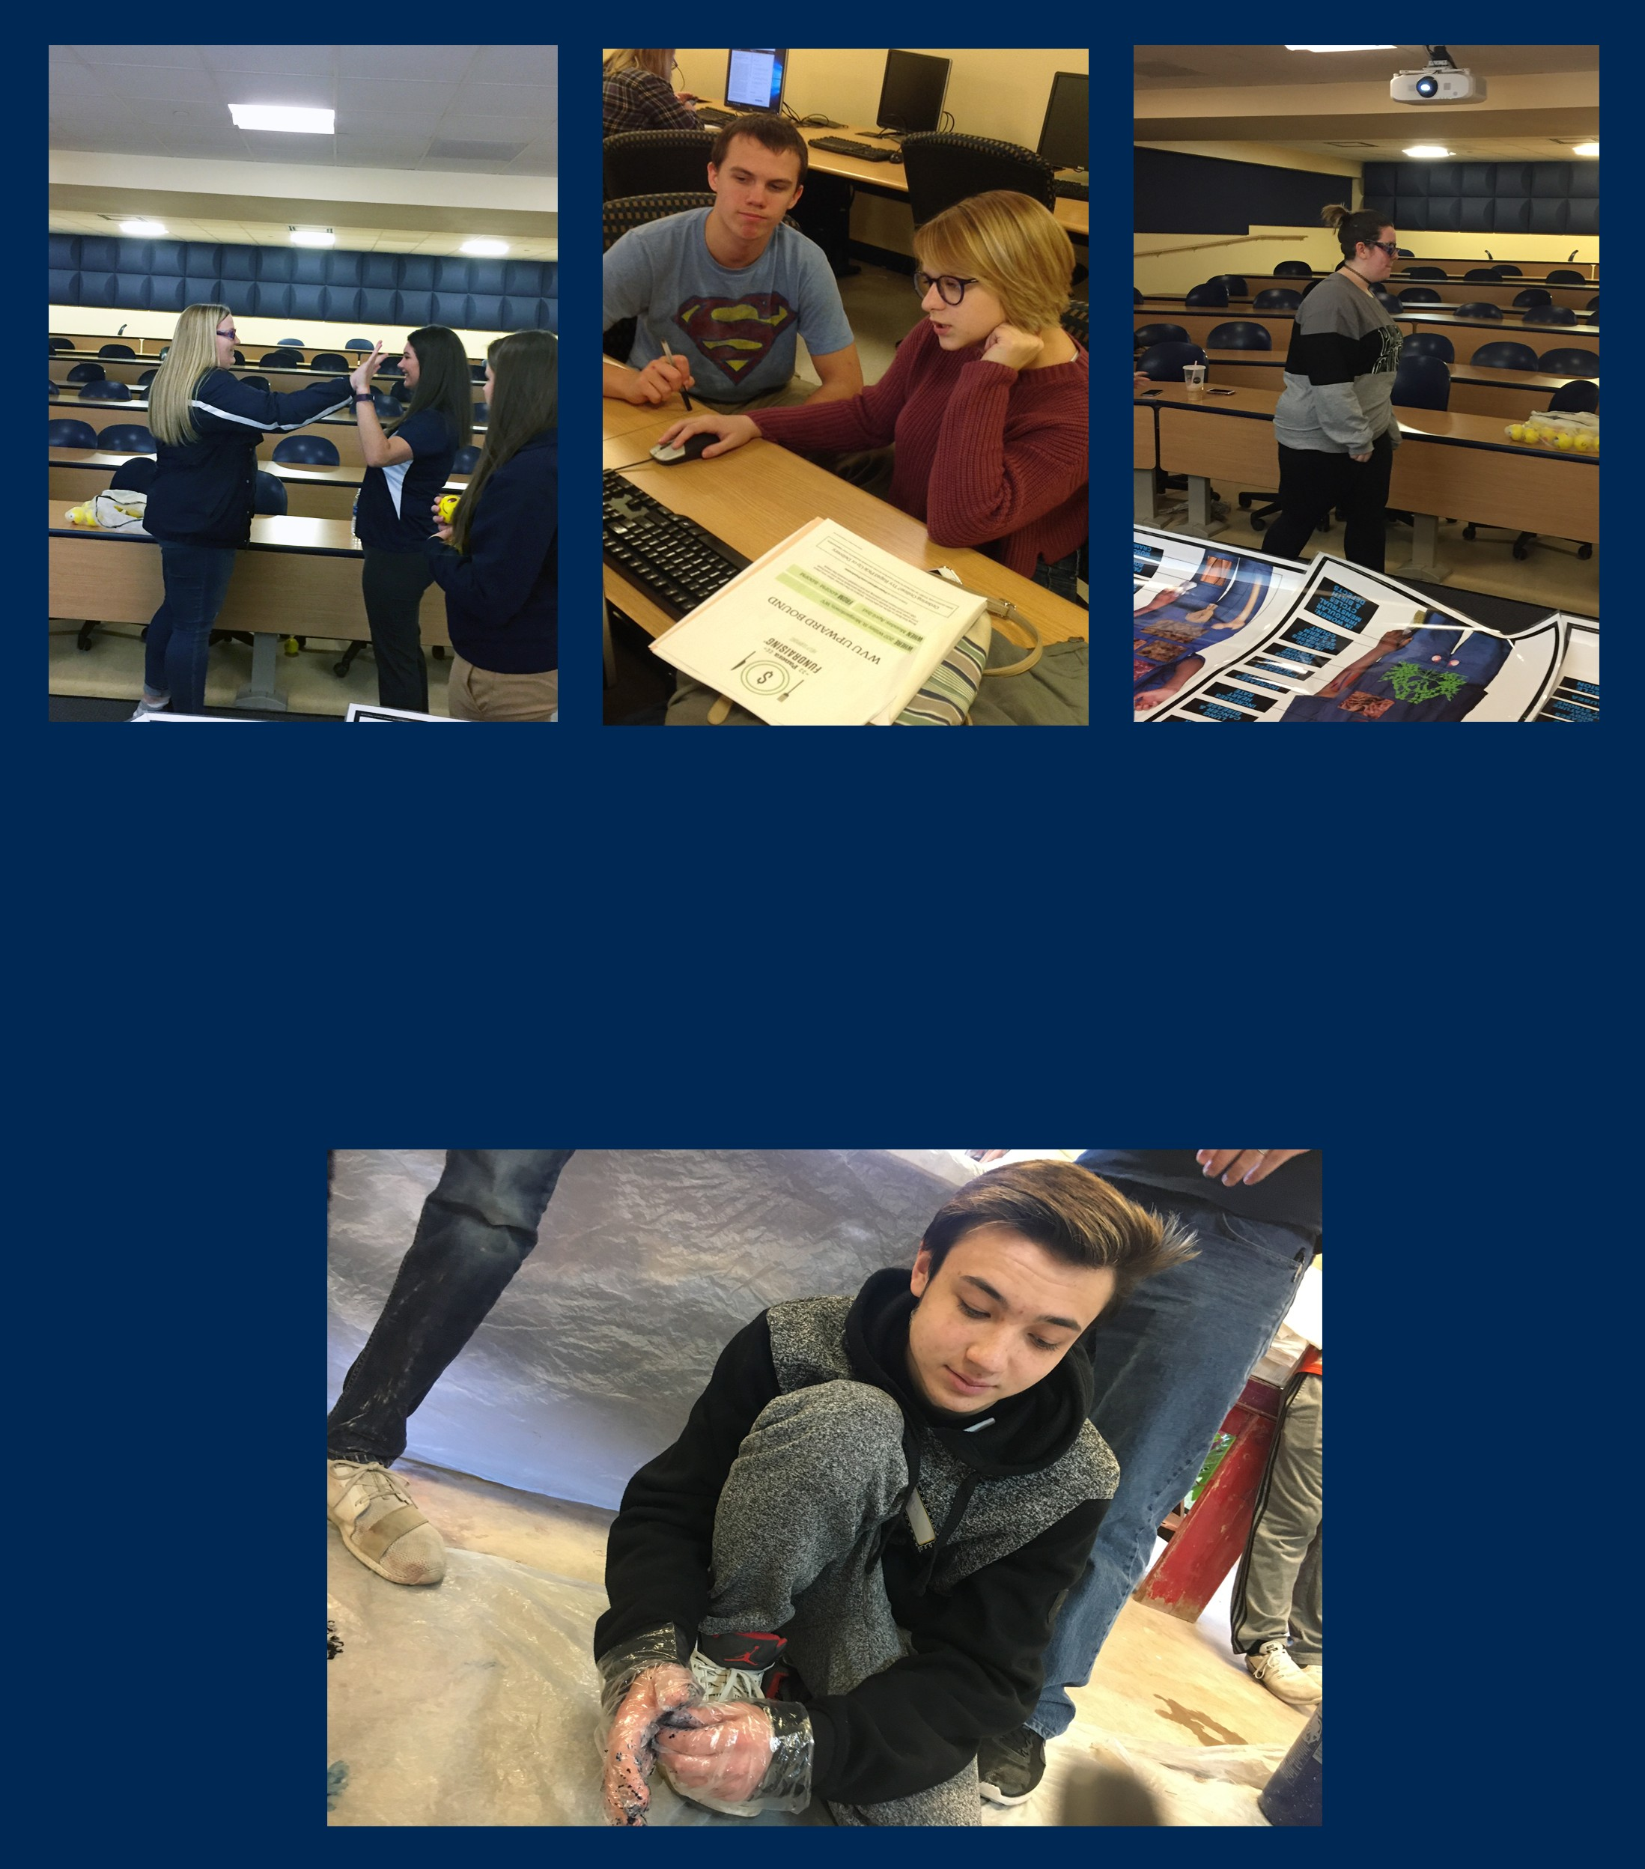MARCH SATURDAY PROGRAM

On March 24, students had fun tie dying t-shirts for themselves . The students also enjoyed a presentation from the School of Pharmacy at WVU. They talked about the eﬀects of drug abuse on a person’s body and brain. After everyone got together and ate lunch, students went to the computer lab to complete a college readiness checklist.
Upperclassmen learned how to sign up for ACT/SAT tests and fill out college related applications while underclassmen completed SAT practice tests.

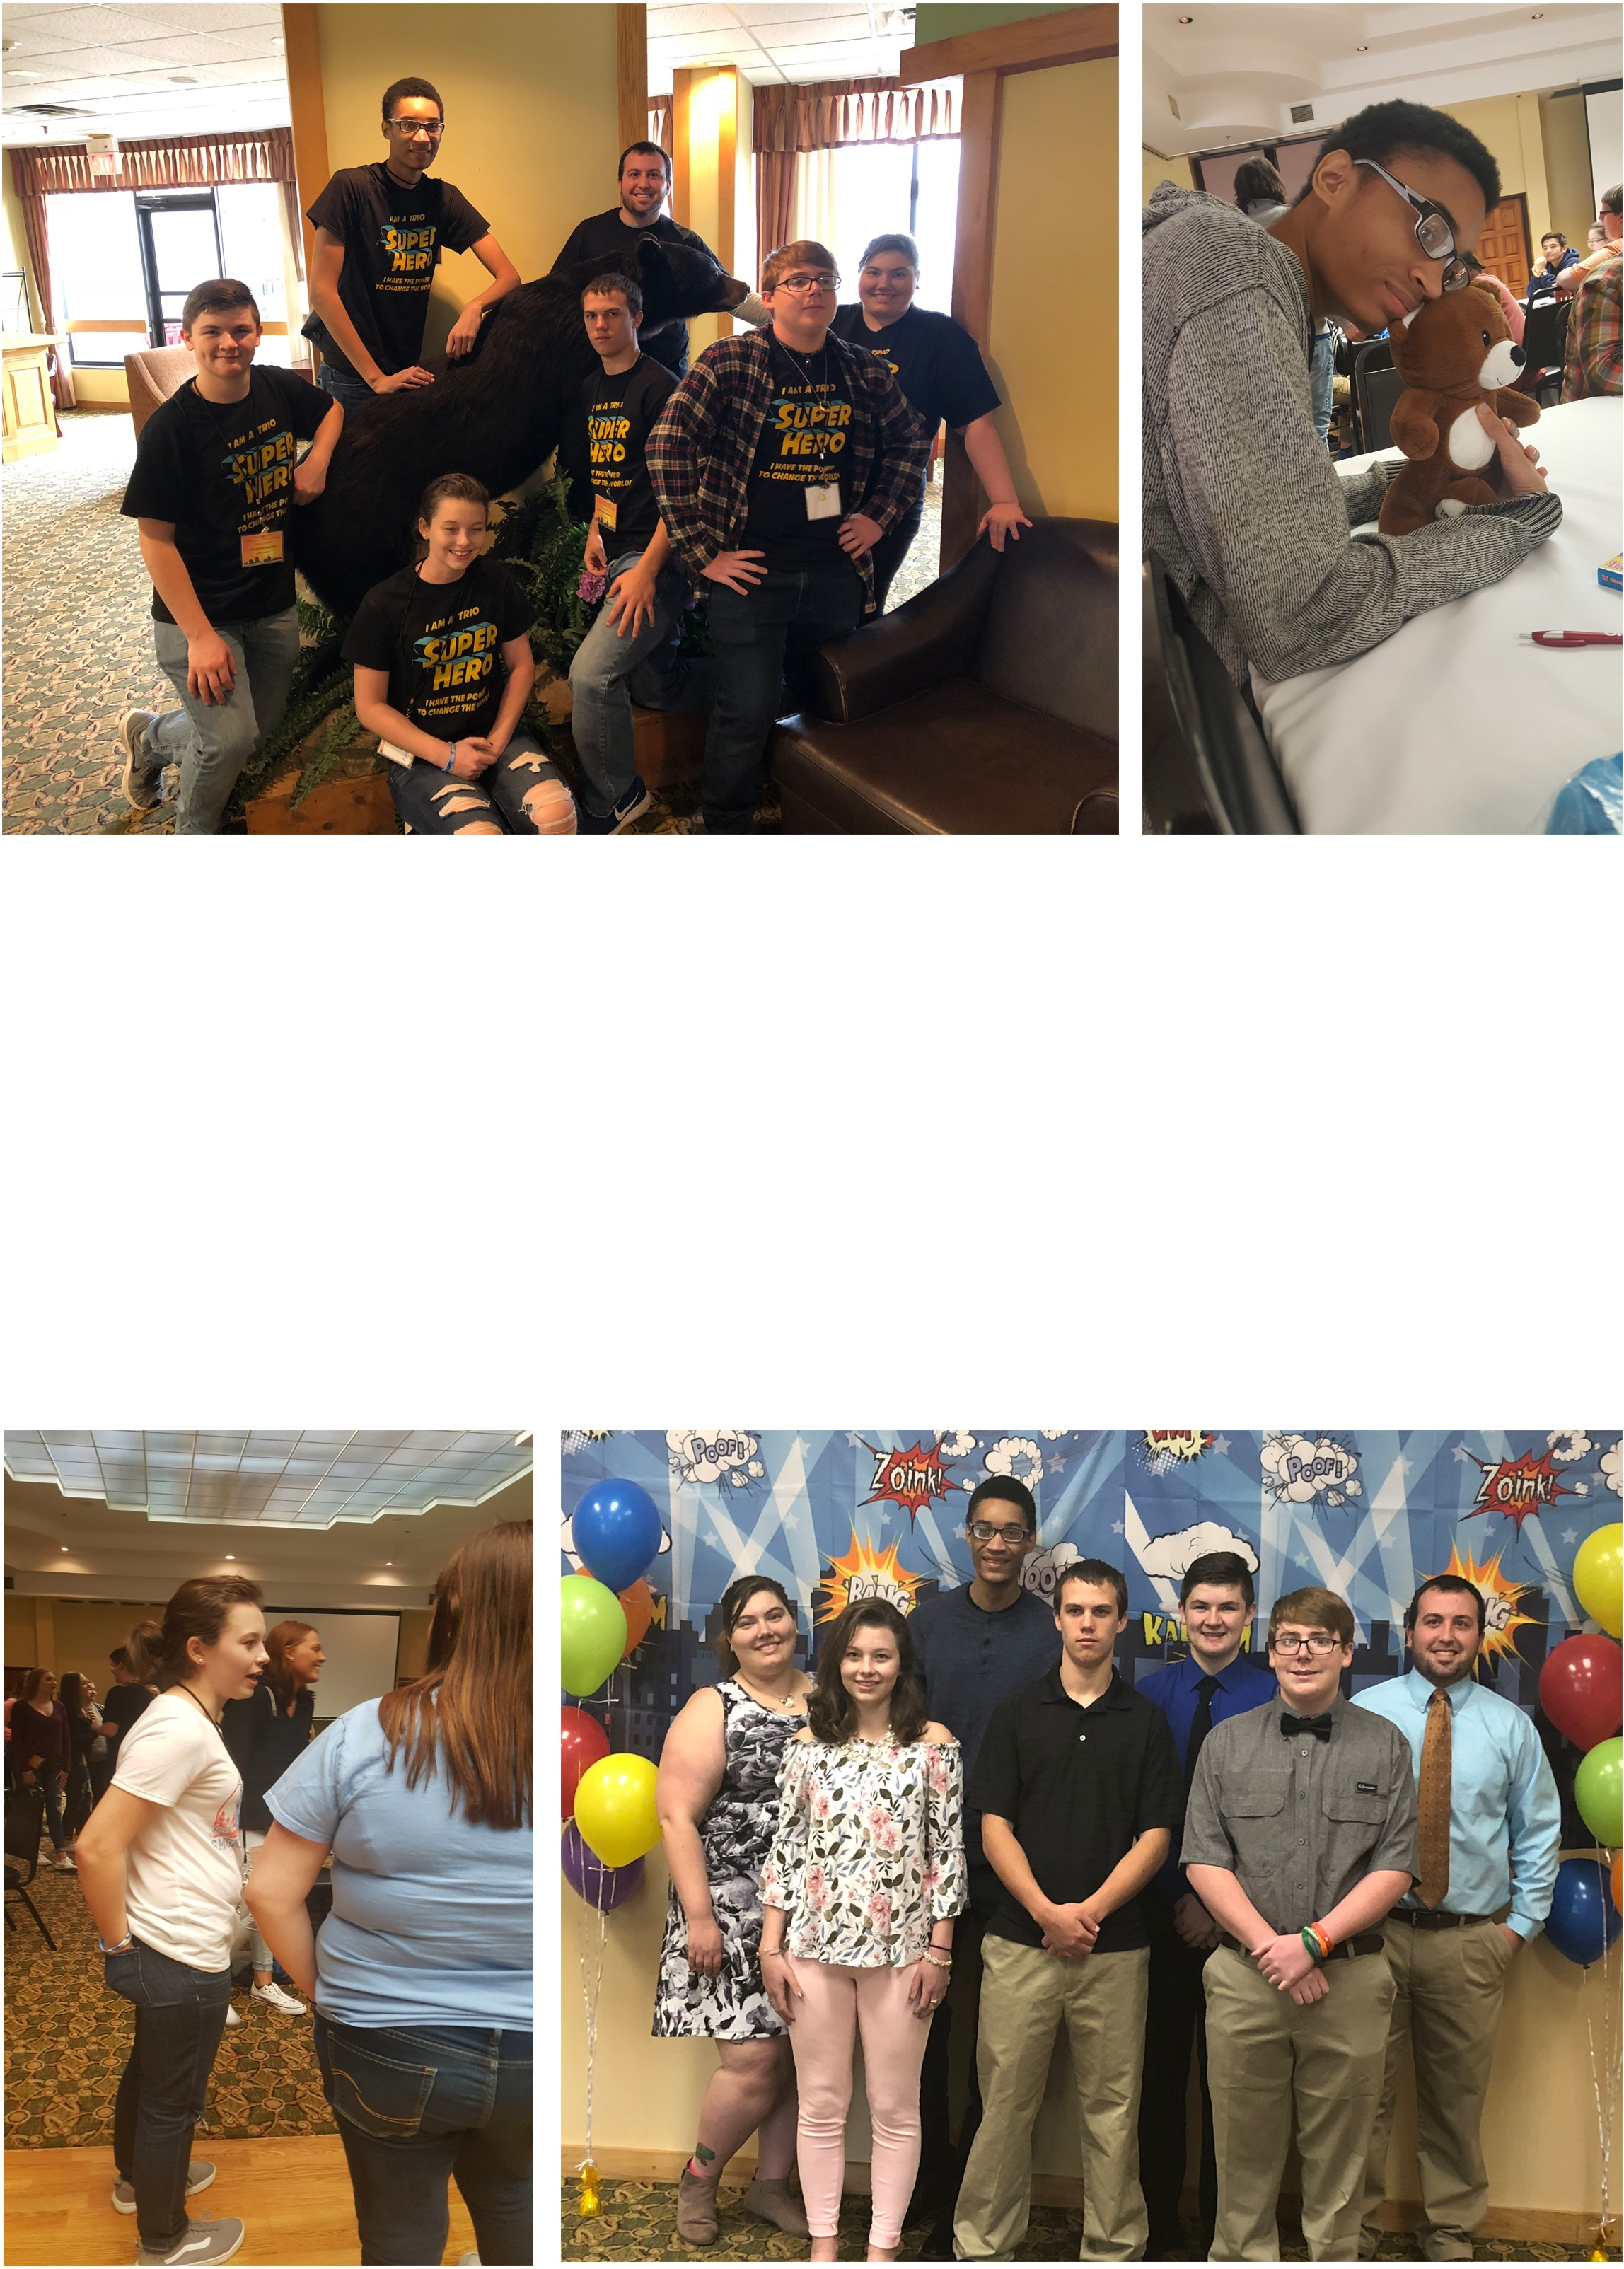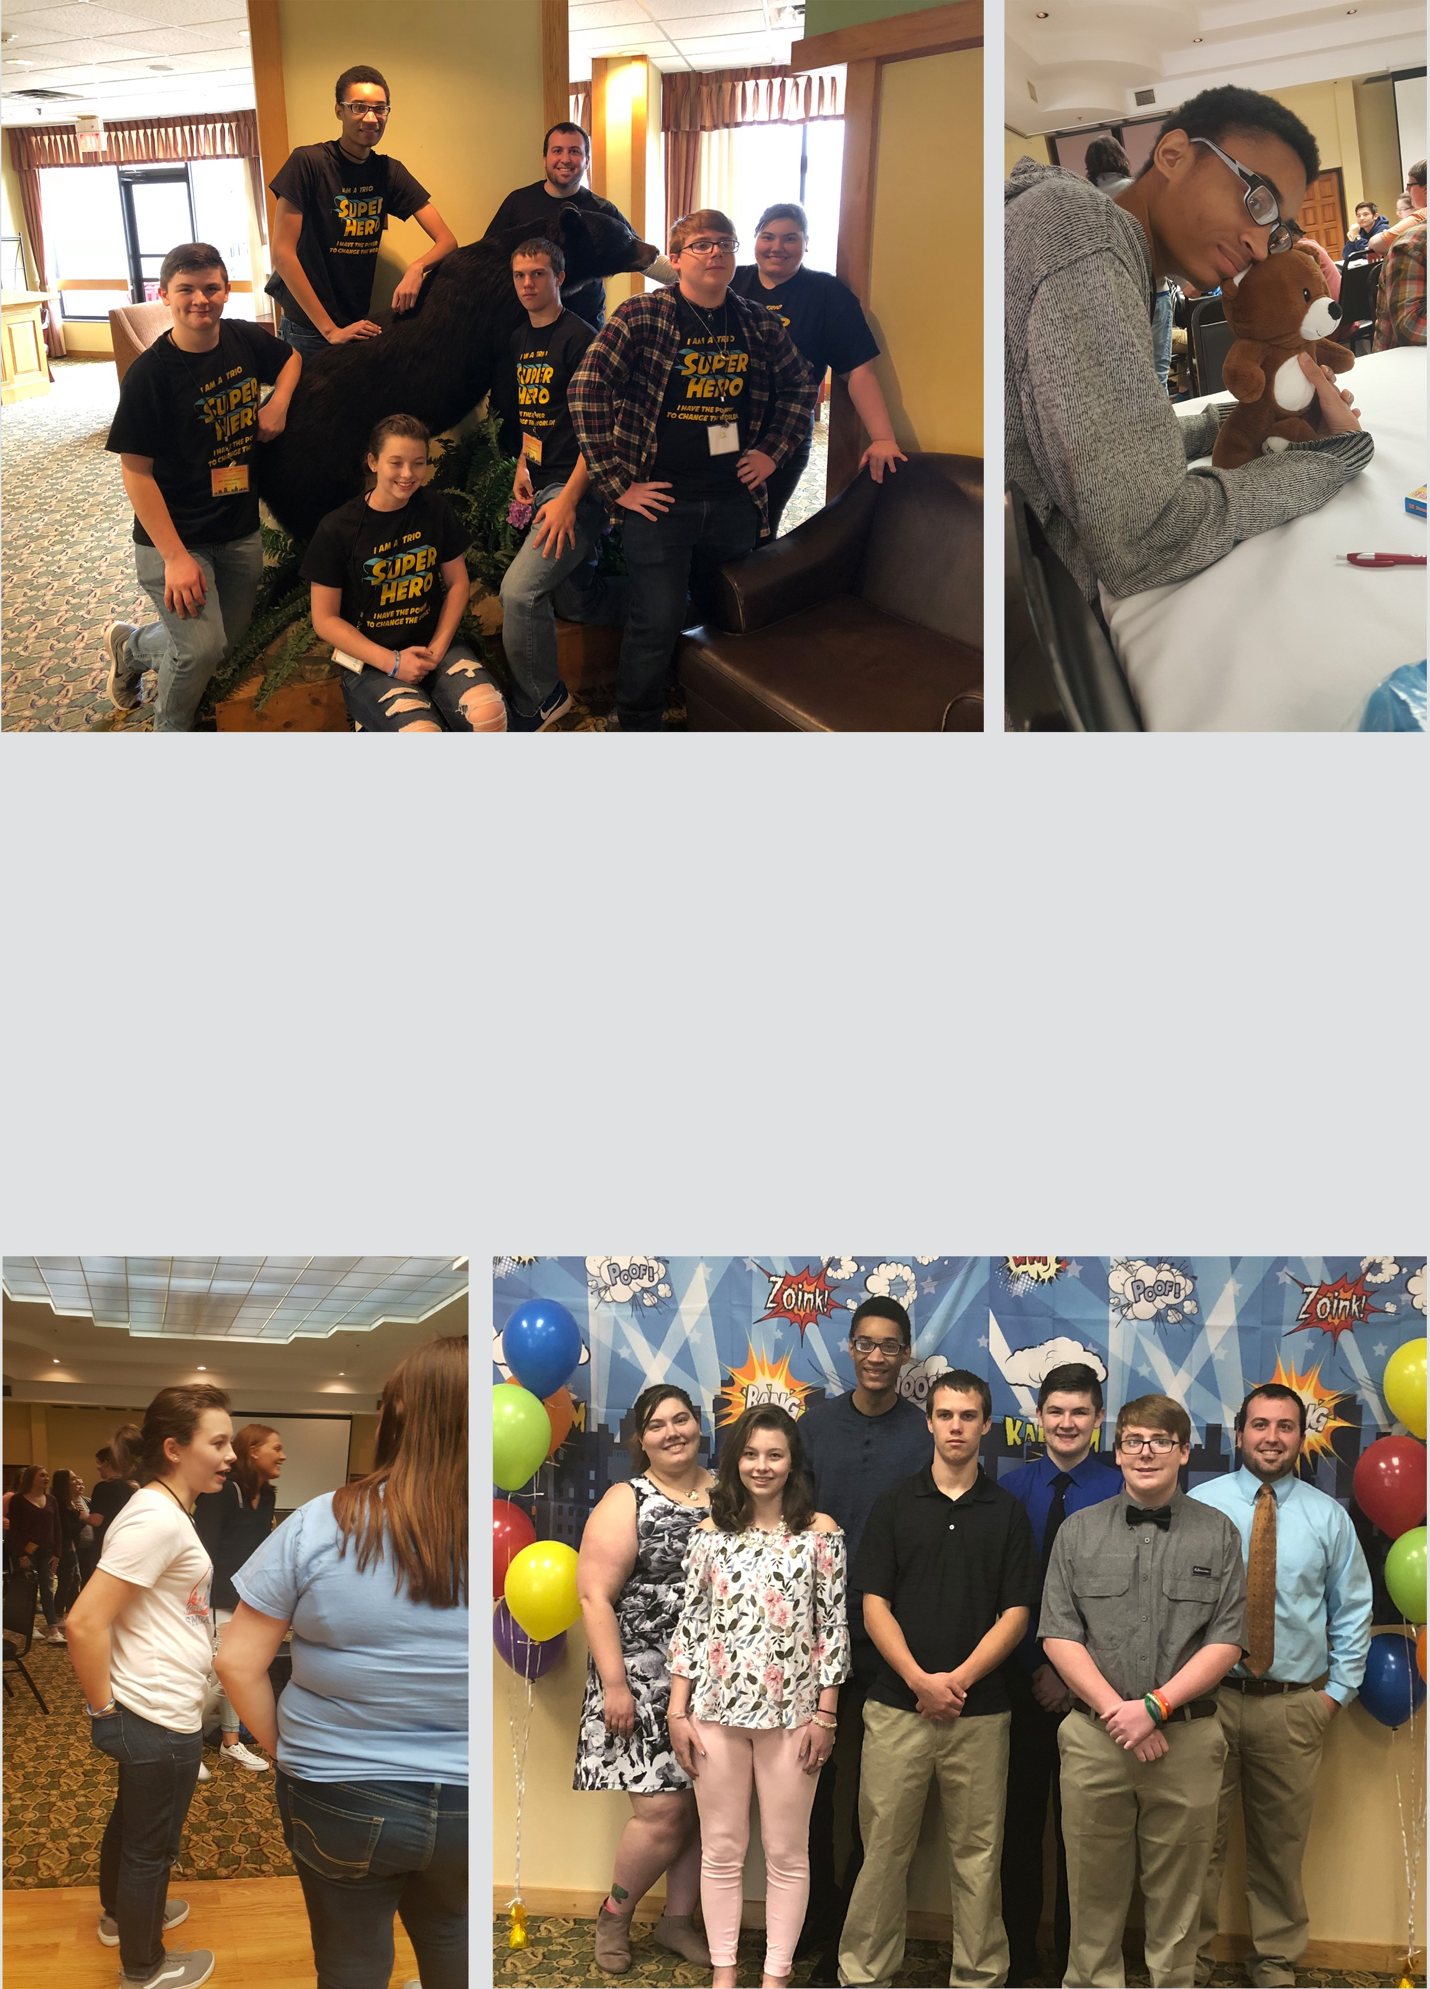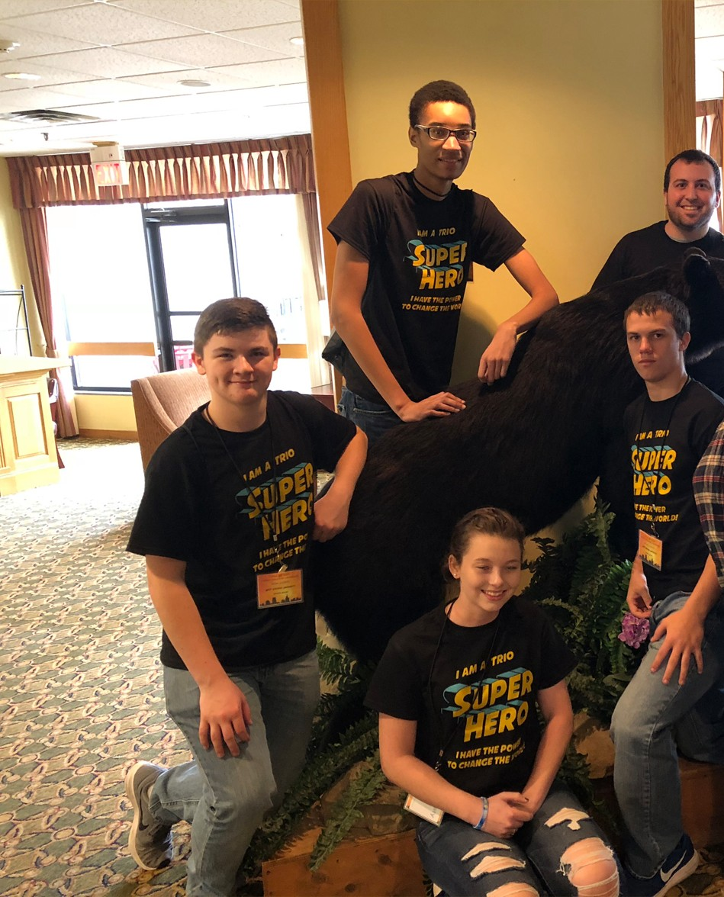

WV TRIO Student Leadership Conference

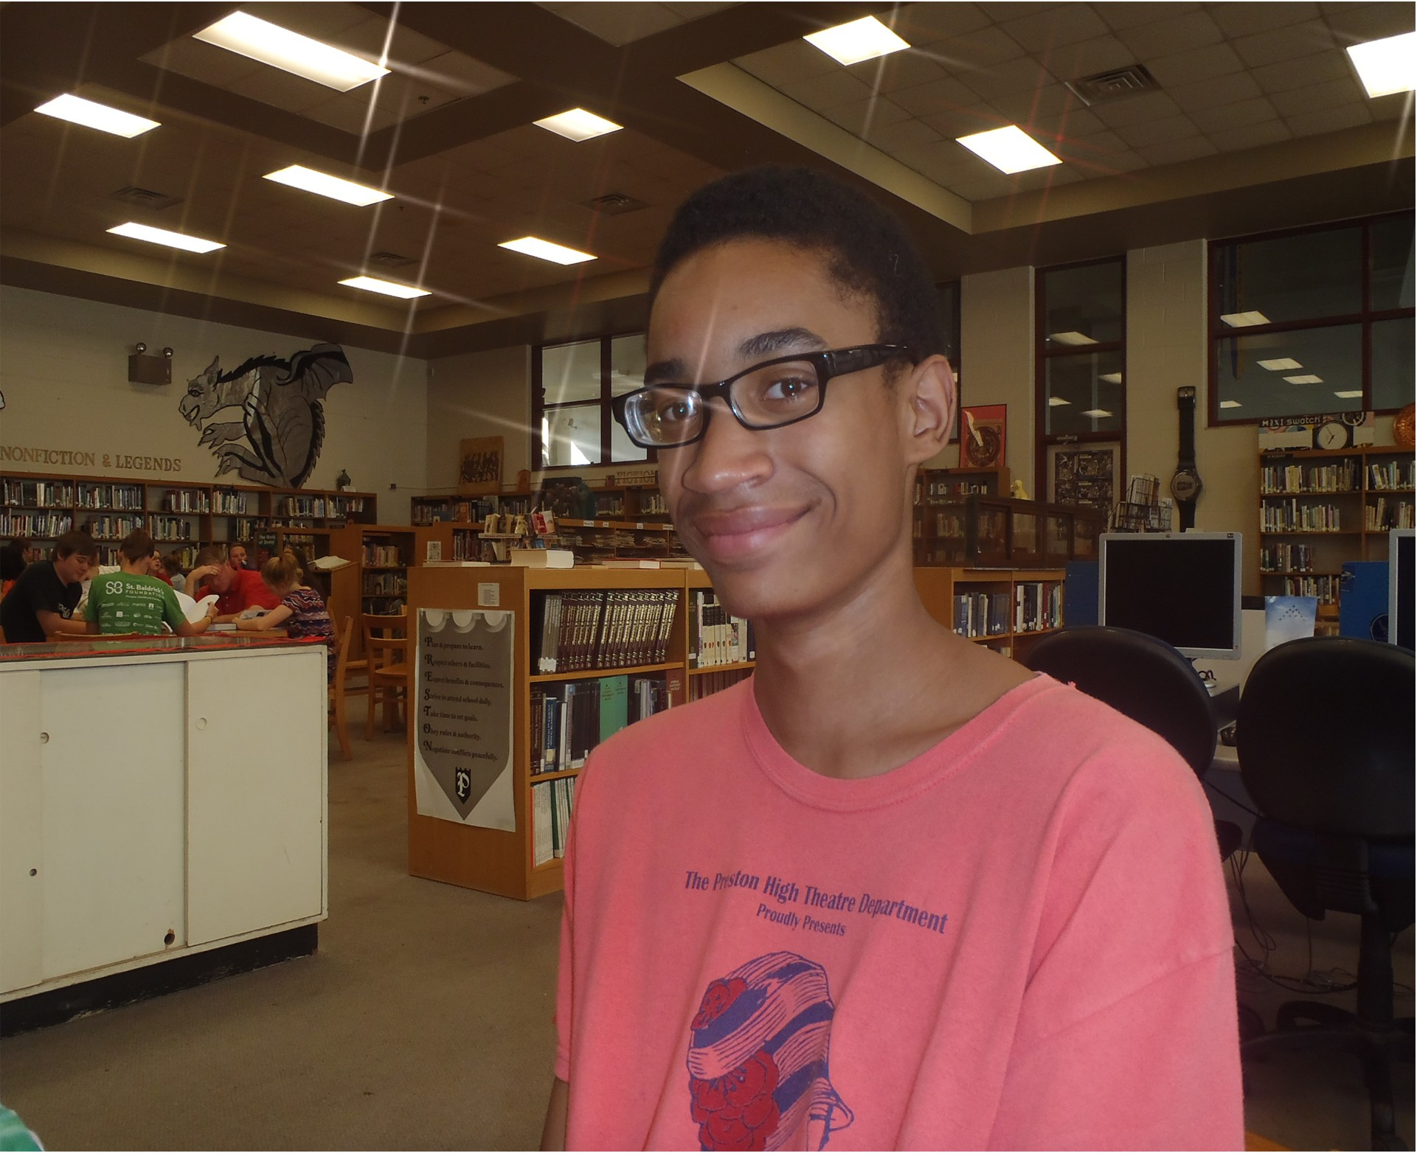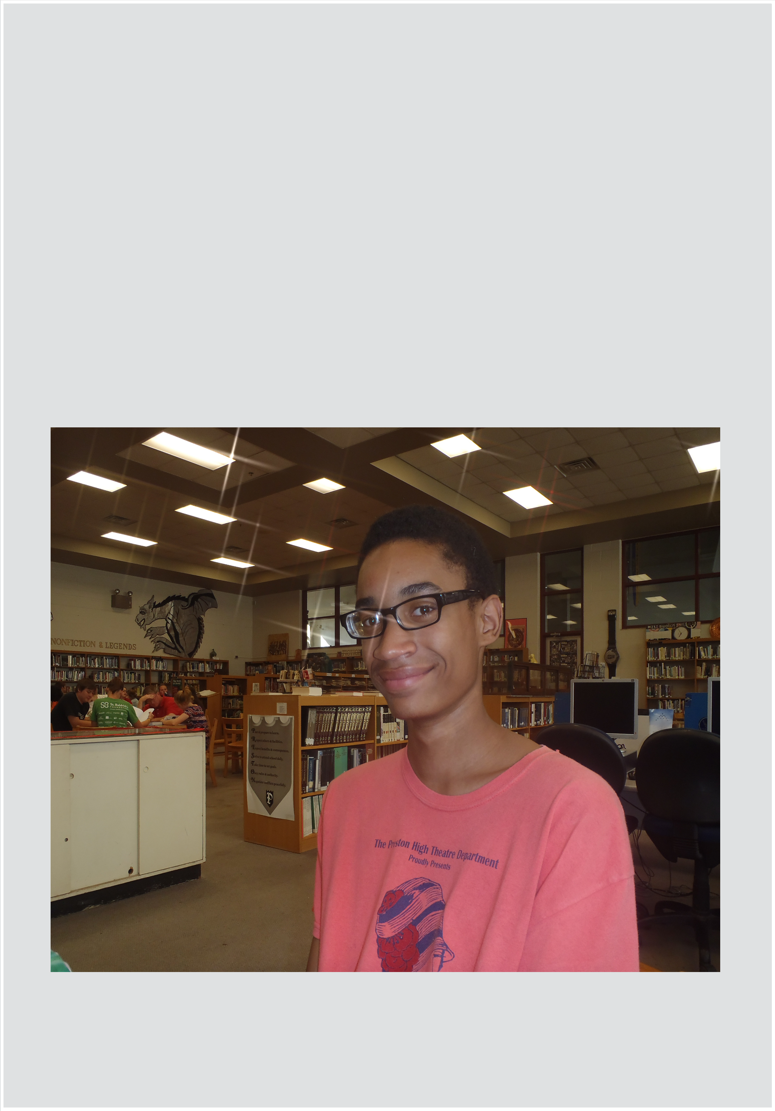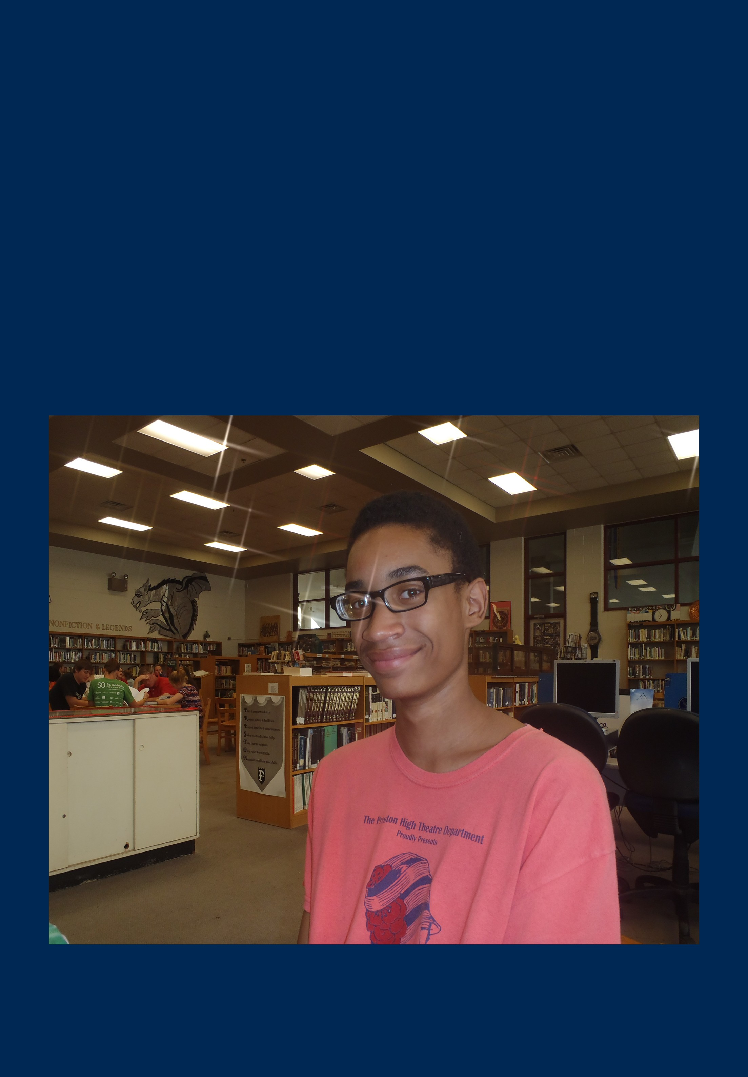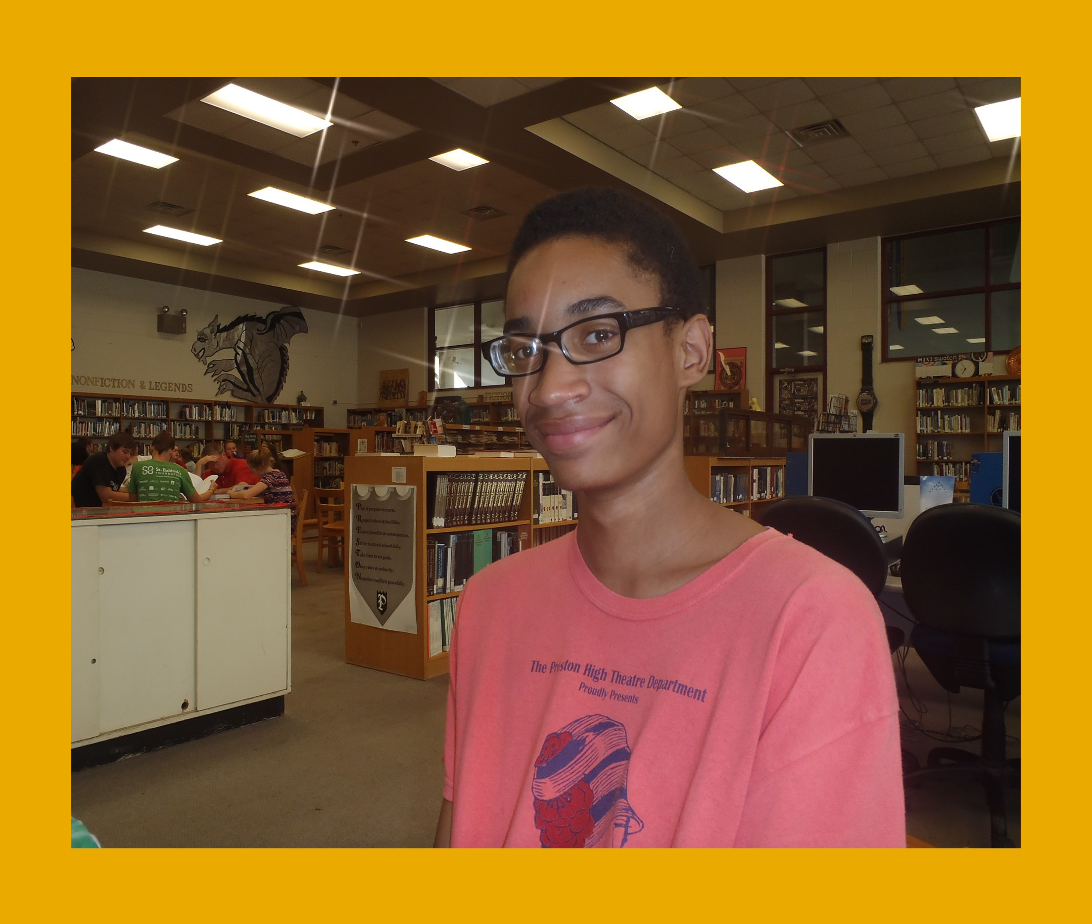Congrats to Isaiah Hardy for winning the $100 Dr. Anne Crum Directors Award at this year’s WV TRIO Student Leadership Conference

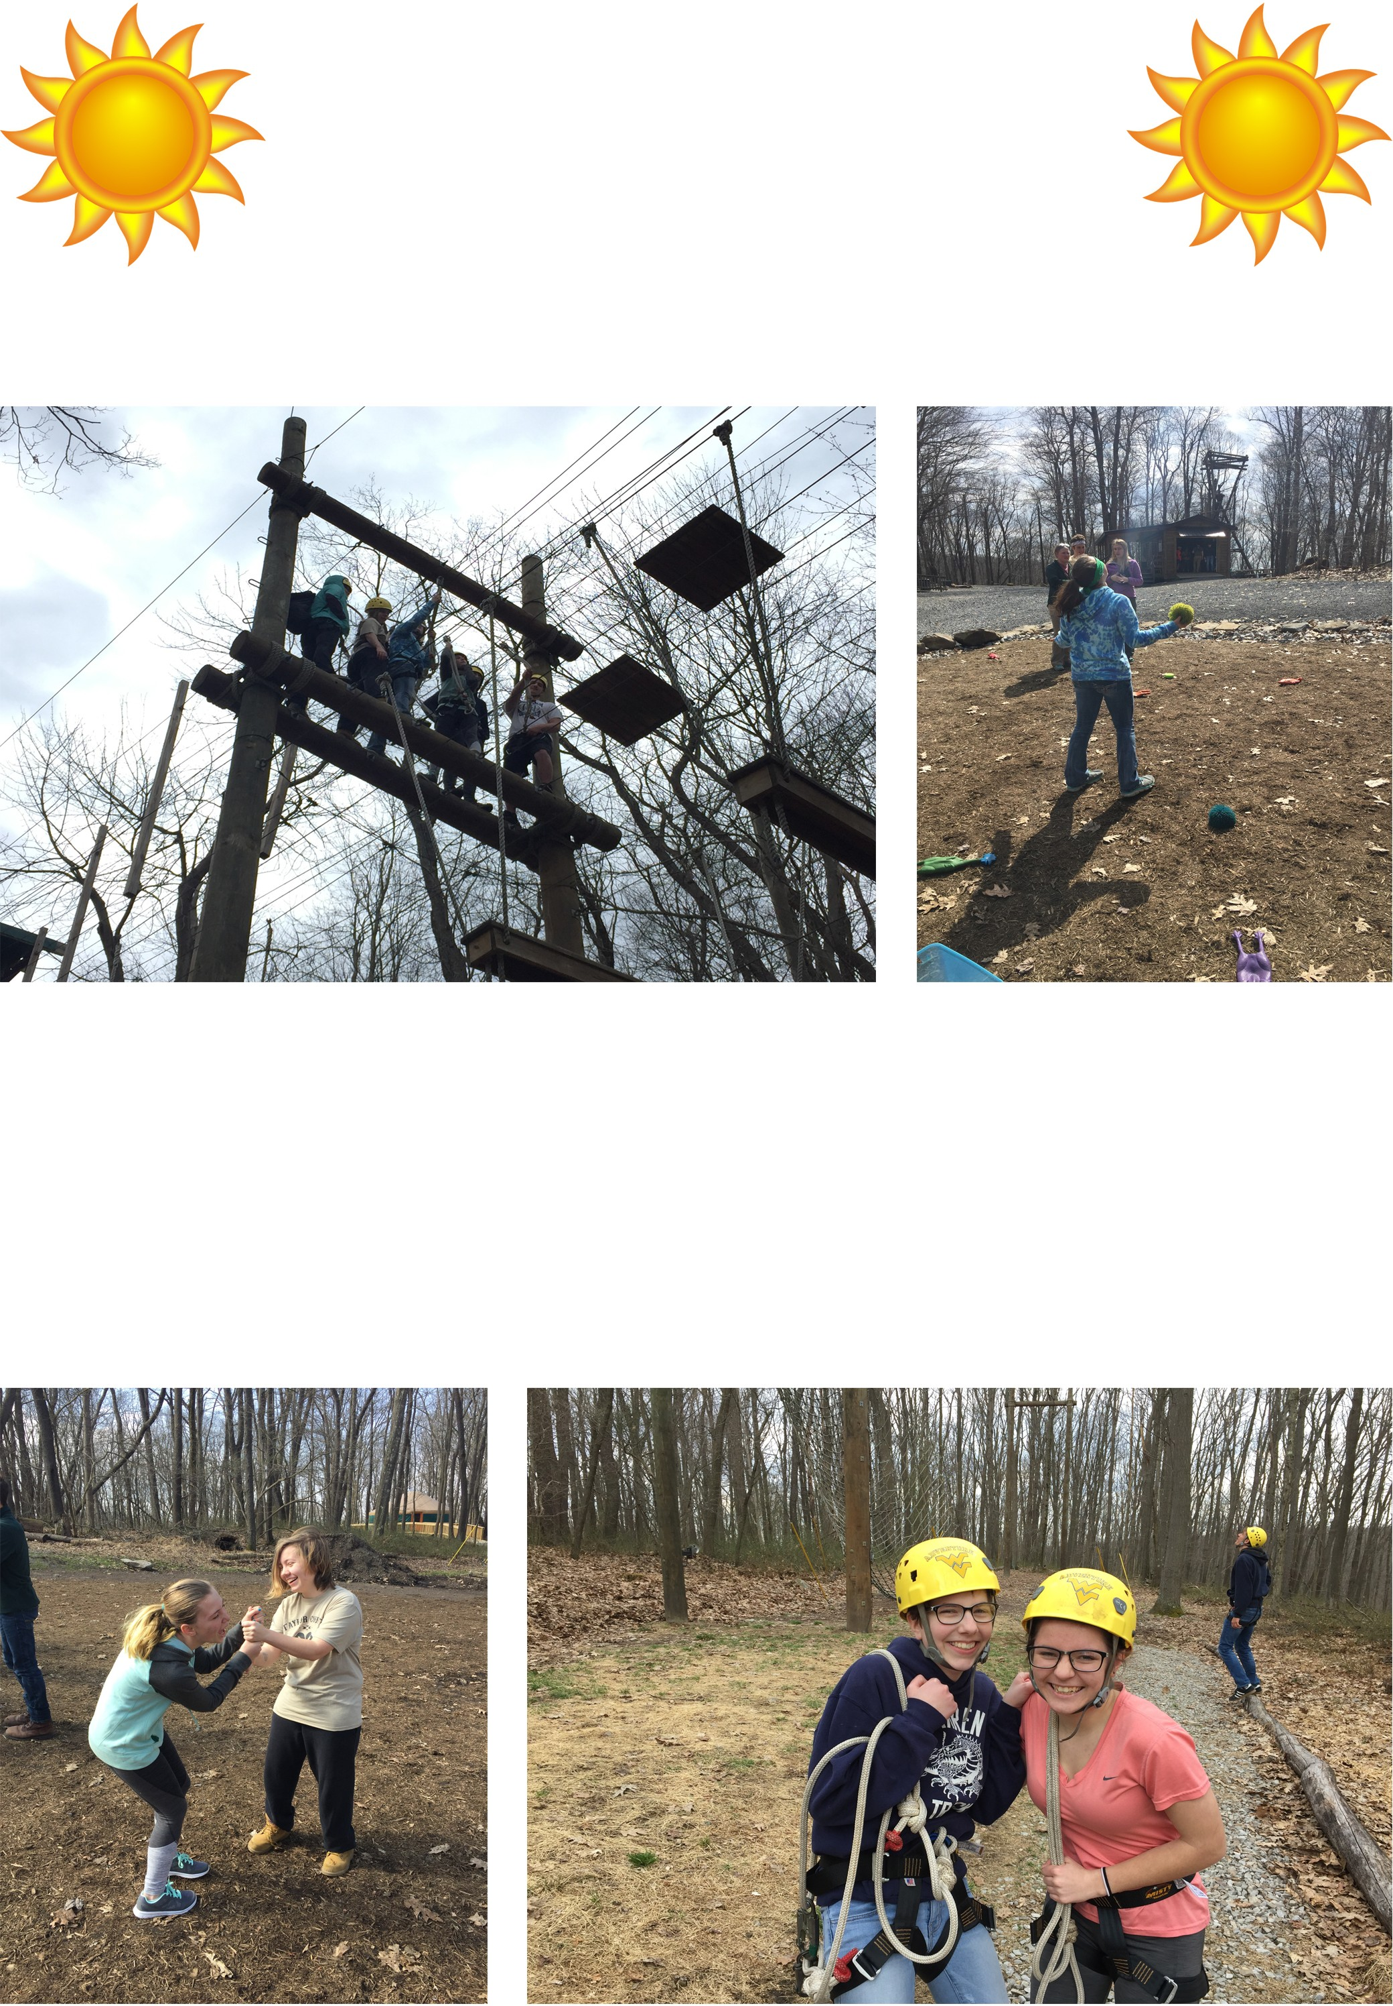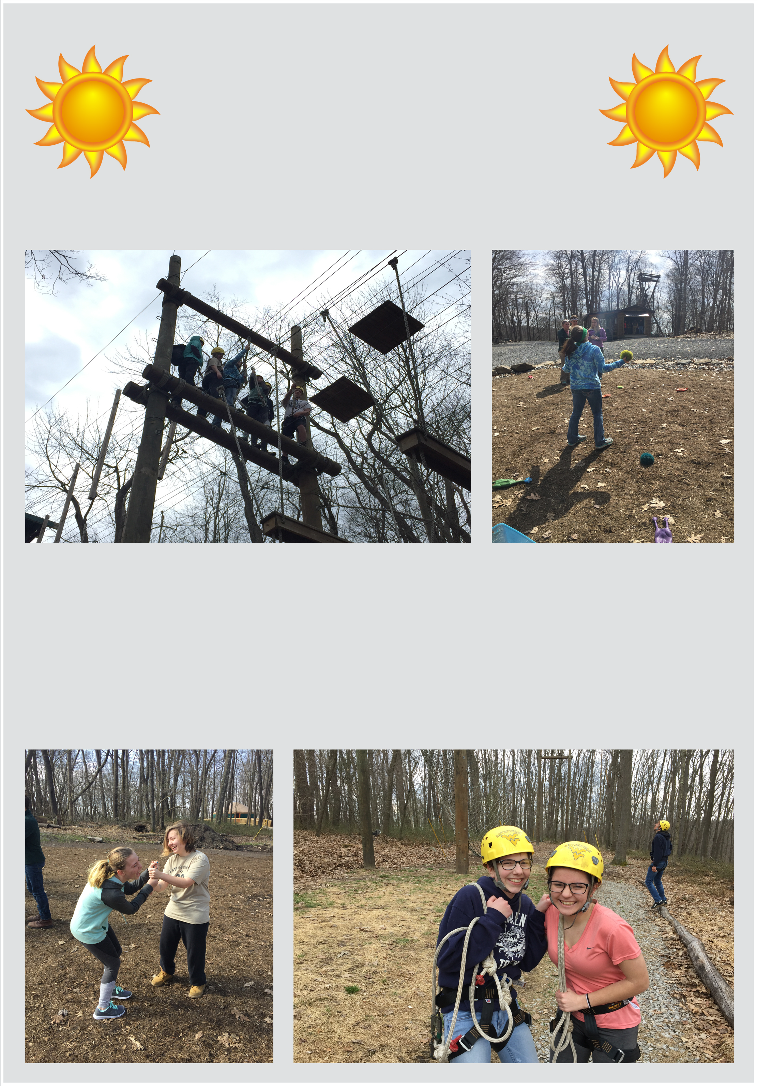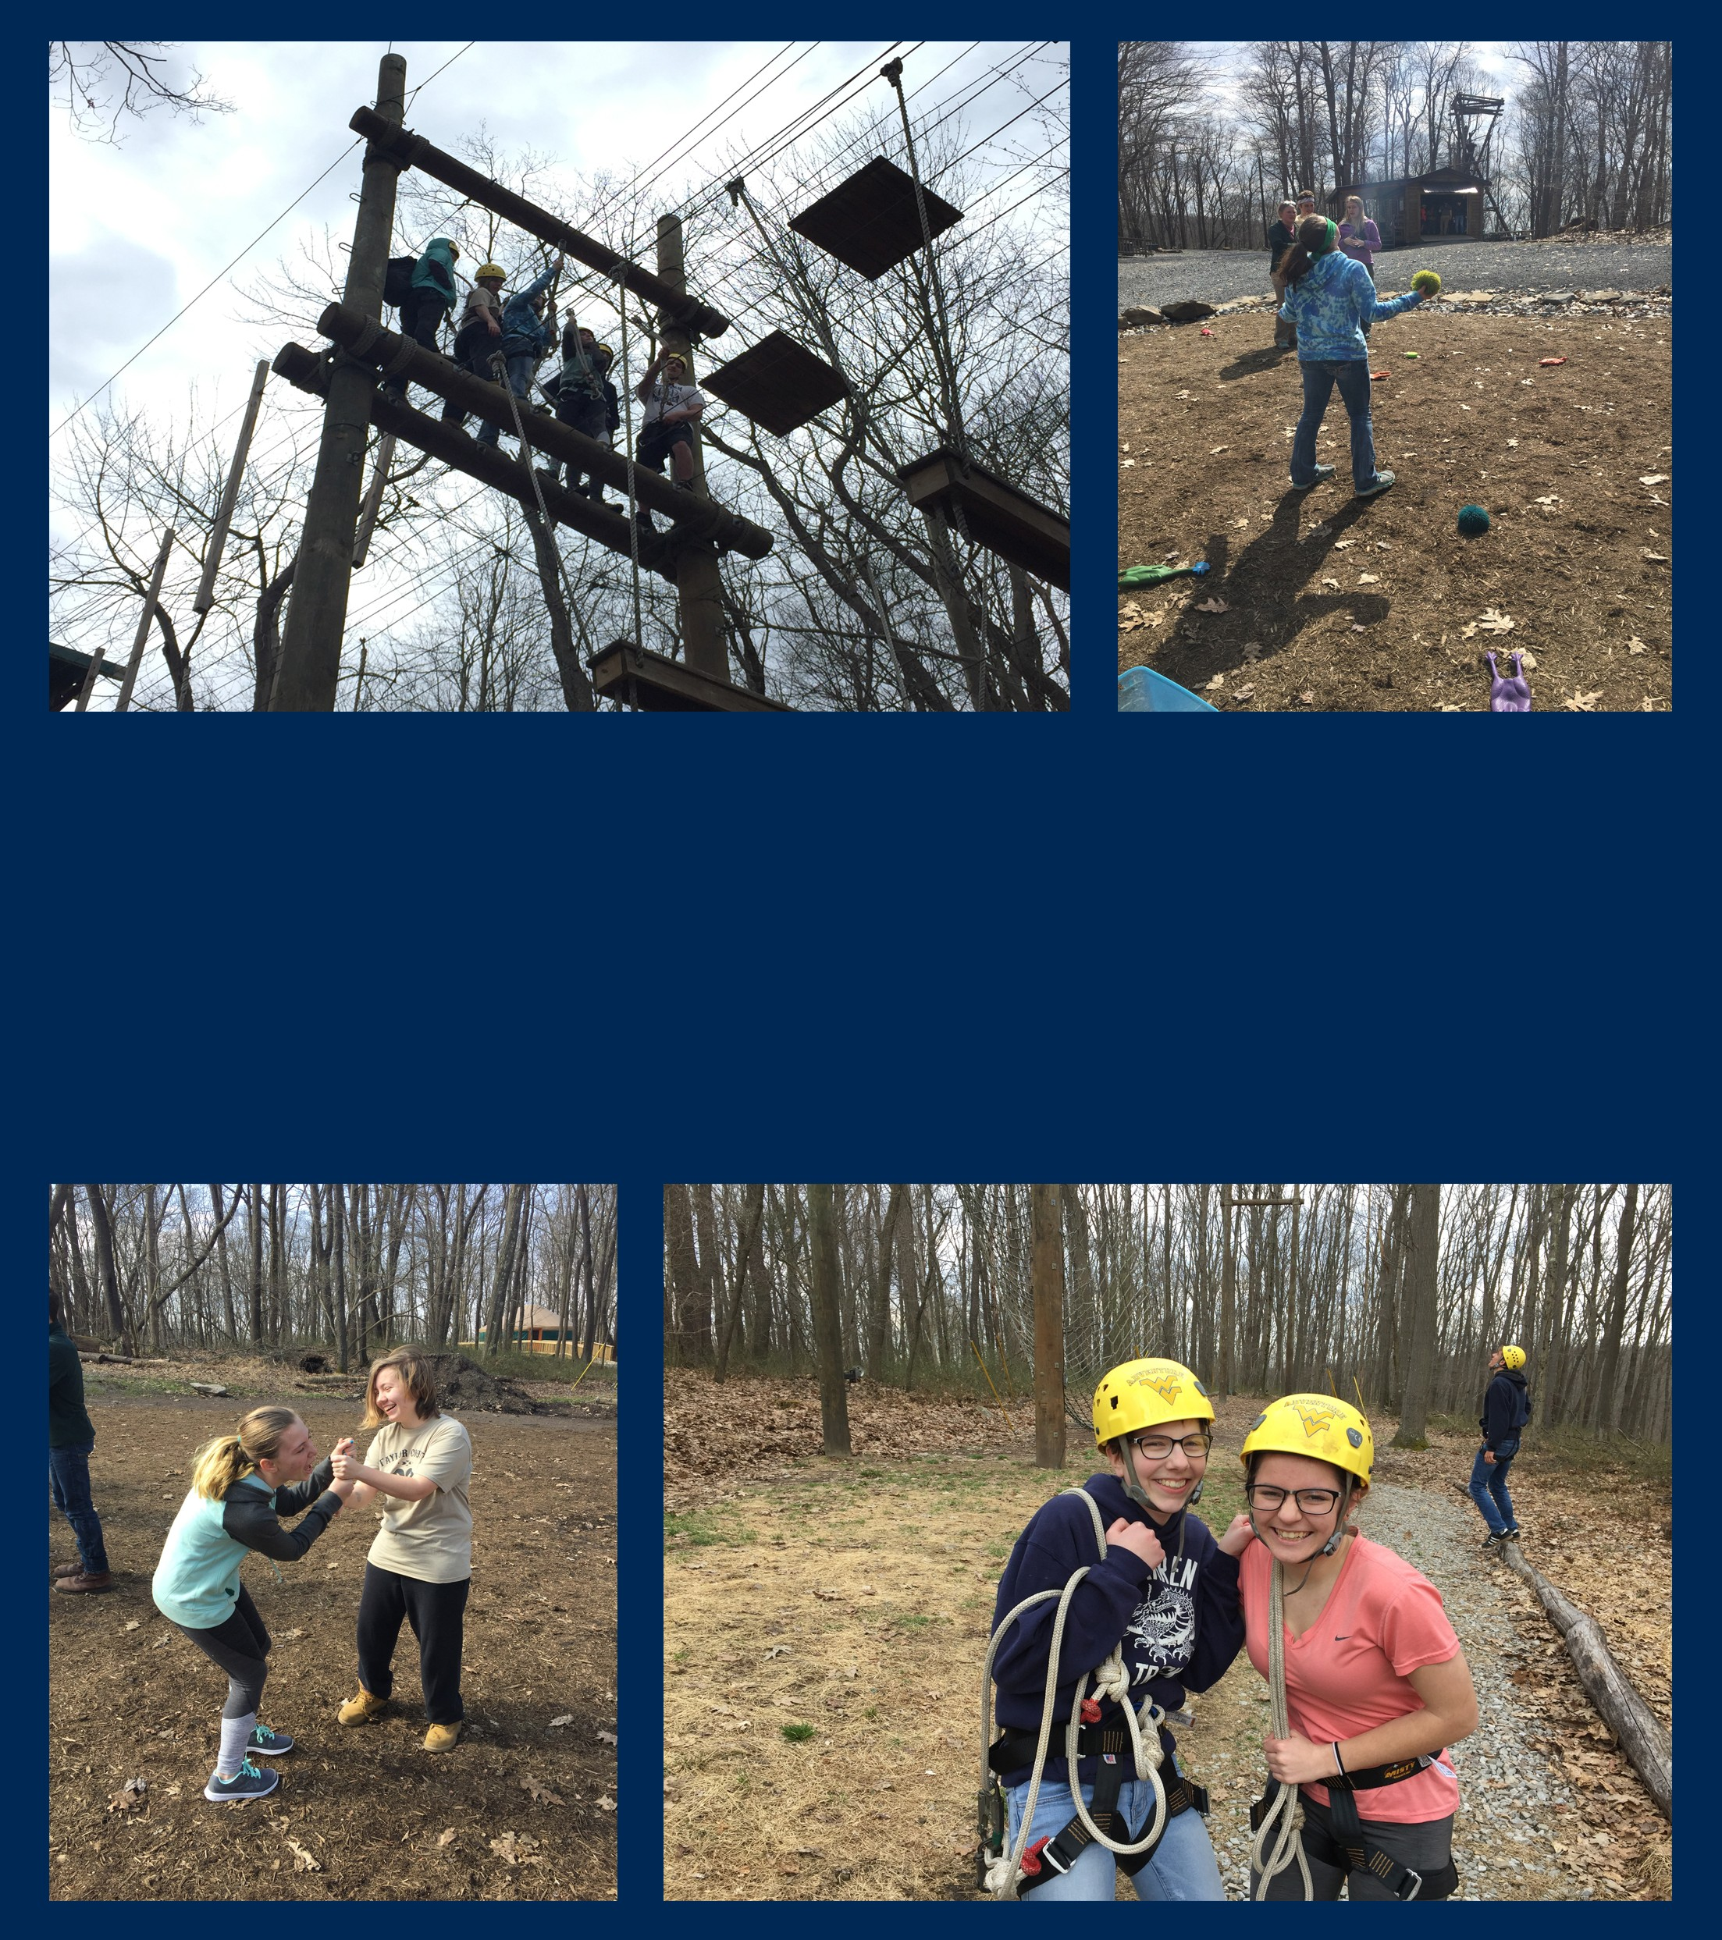APRIL SATURDAY PROGRAM

On April 28, 2018, students went to the Outdoor Education Center to have some fun while learning a little with Adventure WV. First, everyone got in a group and played a couple of team building games. Next, the students climbed their way up to the challenge course where they were strapped to wires up in the air and had to complete an obstacle course. To end the day, everyone went to the Mill Stone for some ice cream.

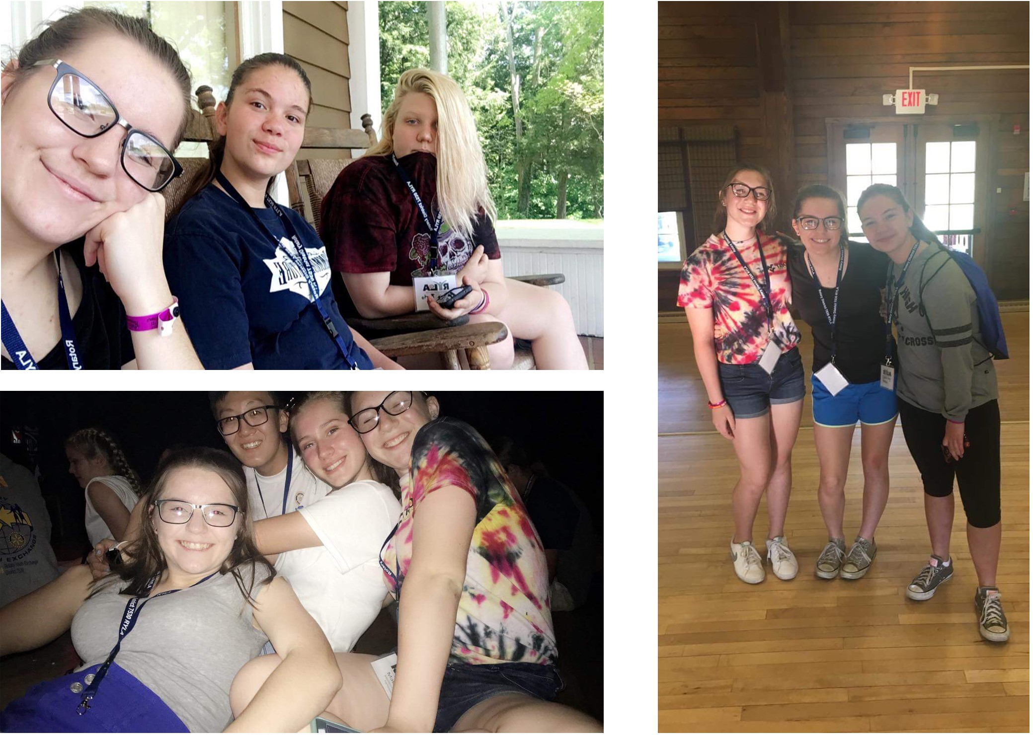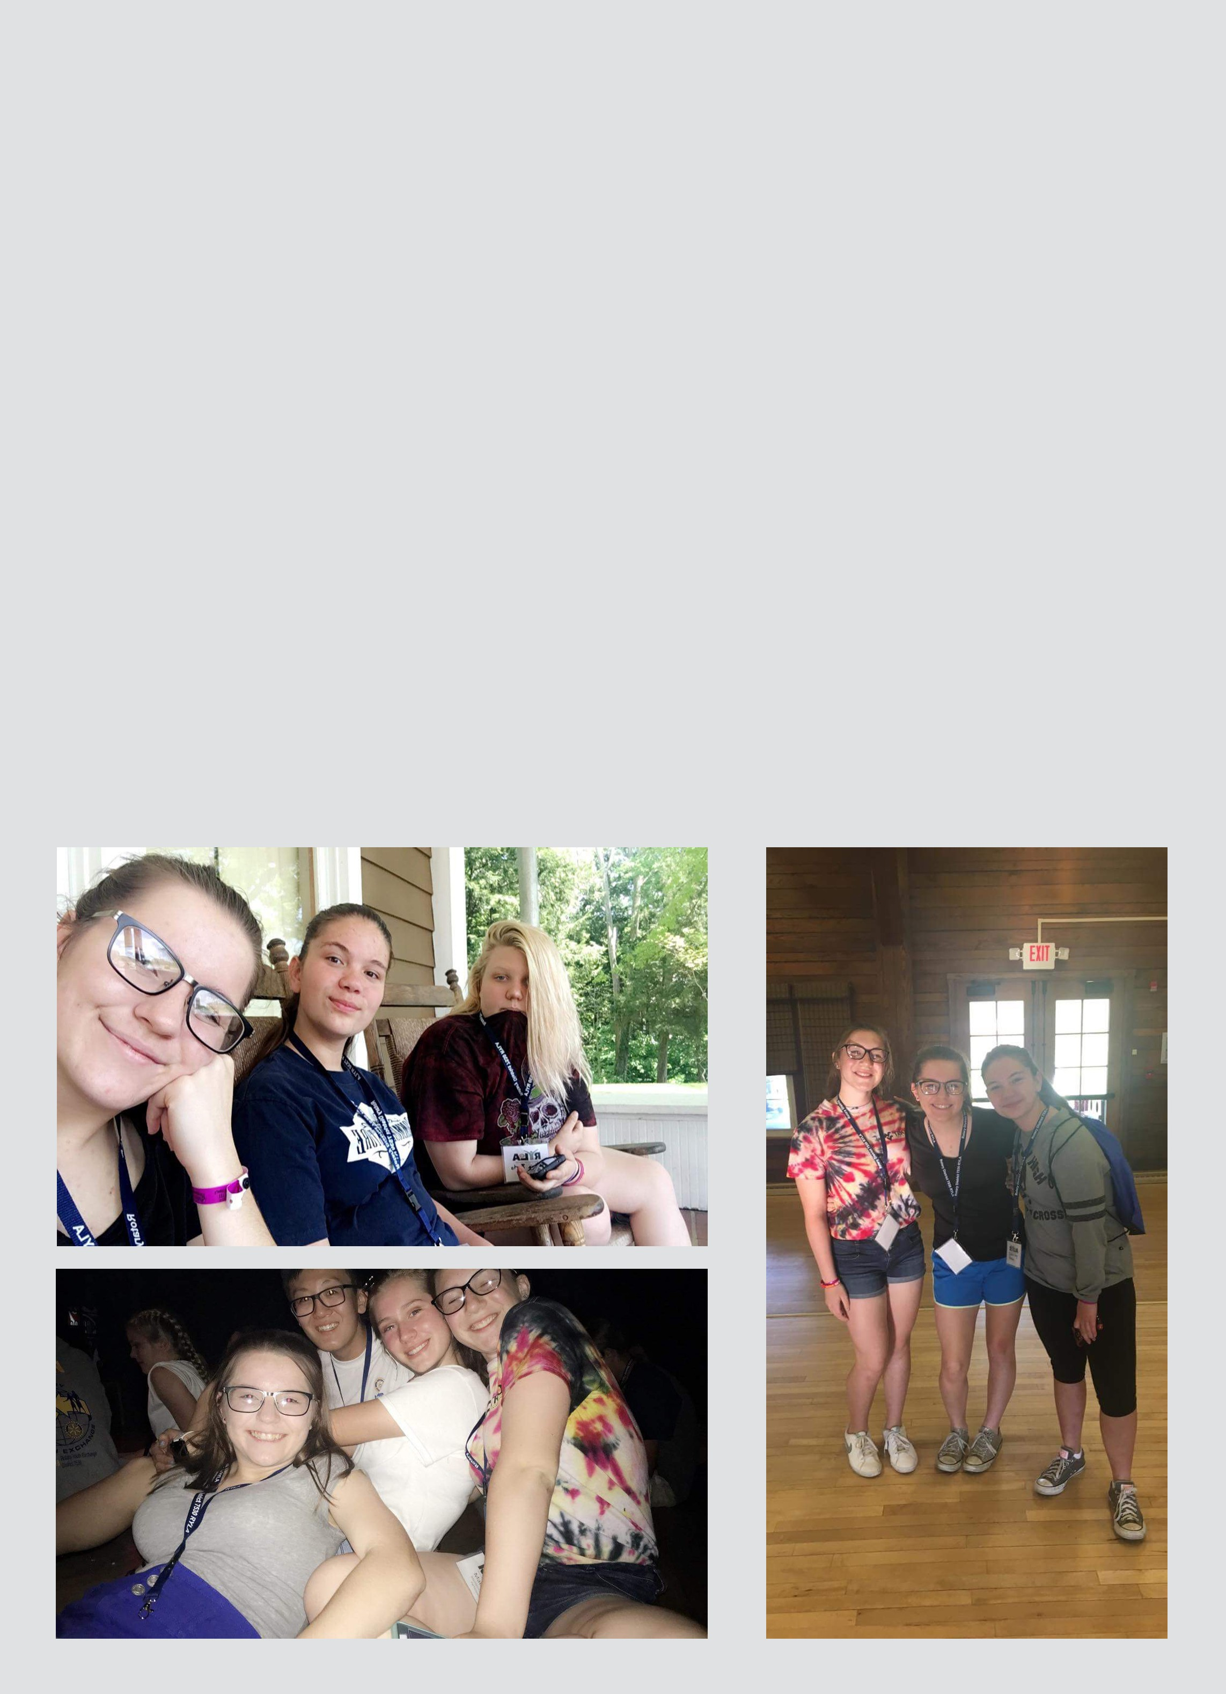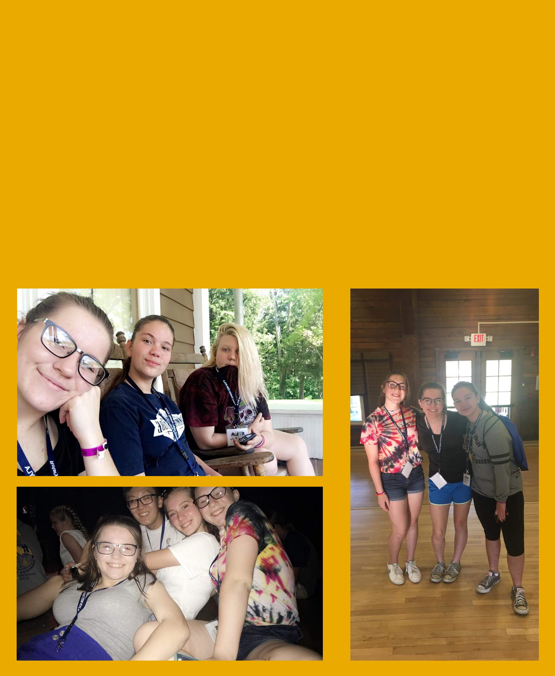Rotary Youth Leadership Awards (RYLA)

RYLA is a program designed for young adults with proven leadership ability and a commitment to community service.
Leah Fisher, Felicia Barto, Madilynn Shreve, and Isabel Long attended this year’s intensive training program gaining exposure to a variety of issues and people all while devoloping leadership skills along the way. They participated in interactive meetings and hands-on service projects and made a few new friends as well.

- Located in Buckhannon, WV
- 70+ student organizations
- 50 majors and 41 minors
- In-state tution: $28,574
- www.wvwc.edu
- Located in Athens, WV
- 20 degrees and programs
- 58 majors and 42 minors
- In-state tution: $7,080
- www.concord.edu

Exploring Colleges

- 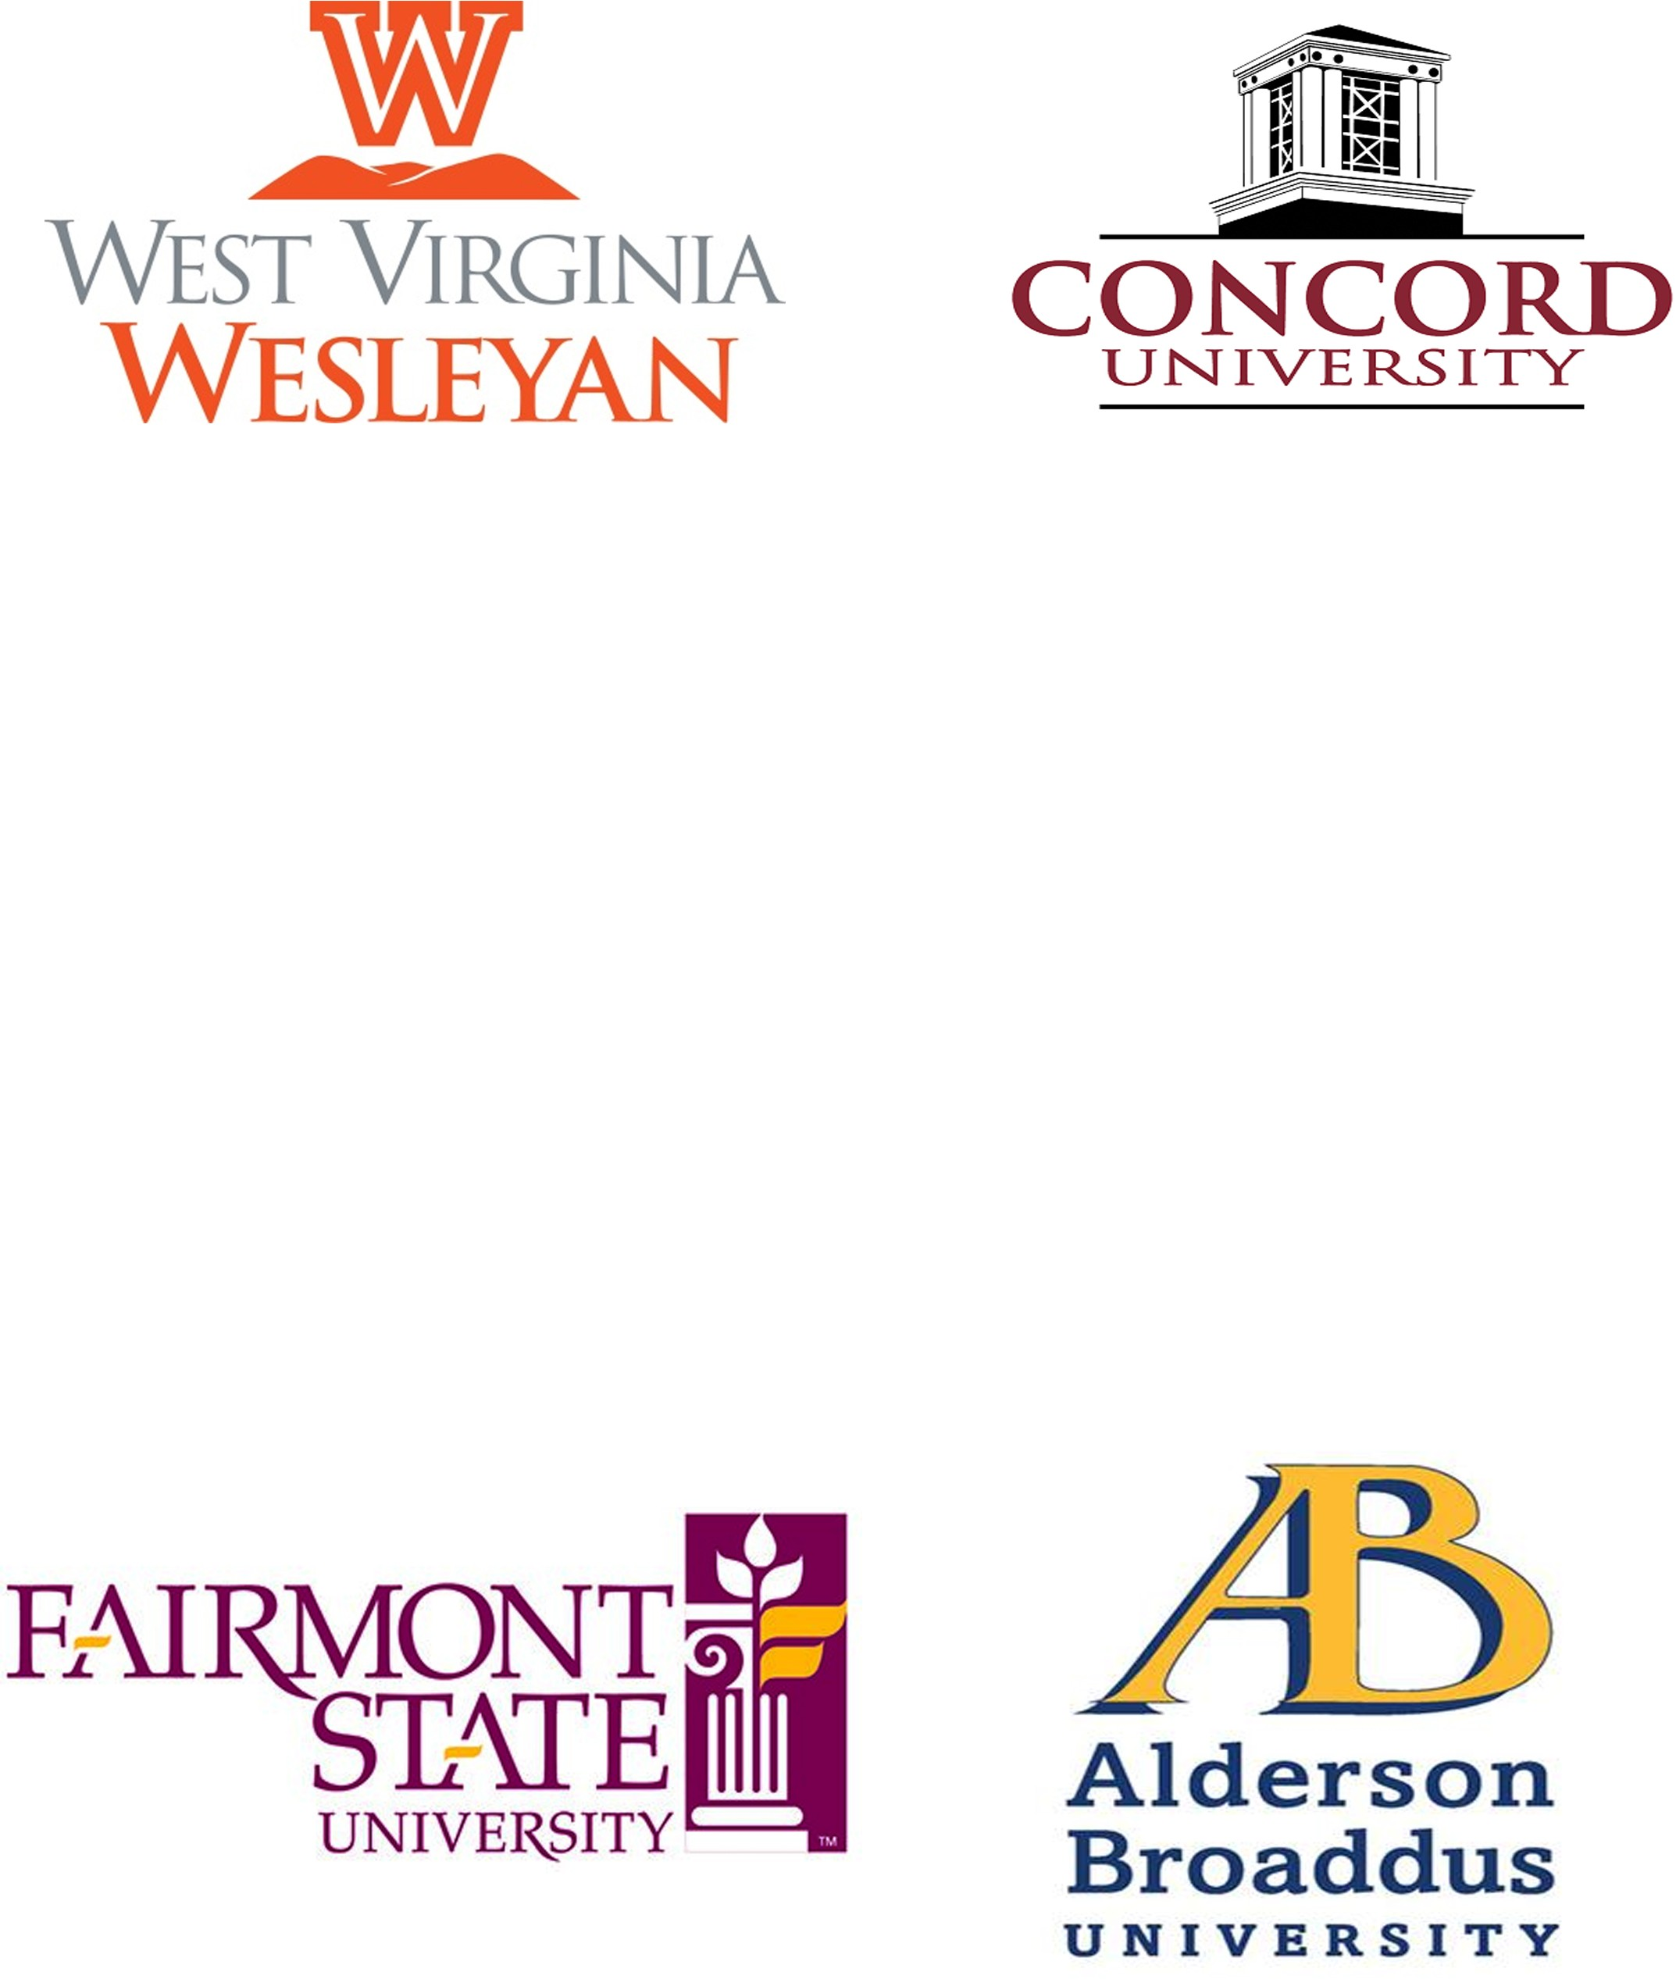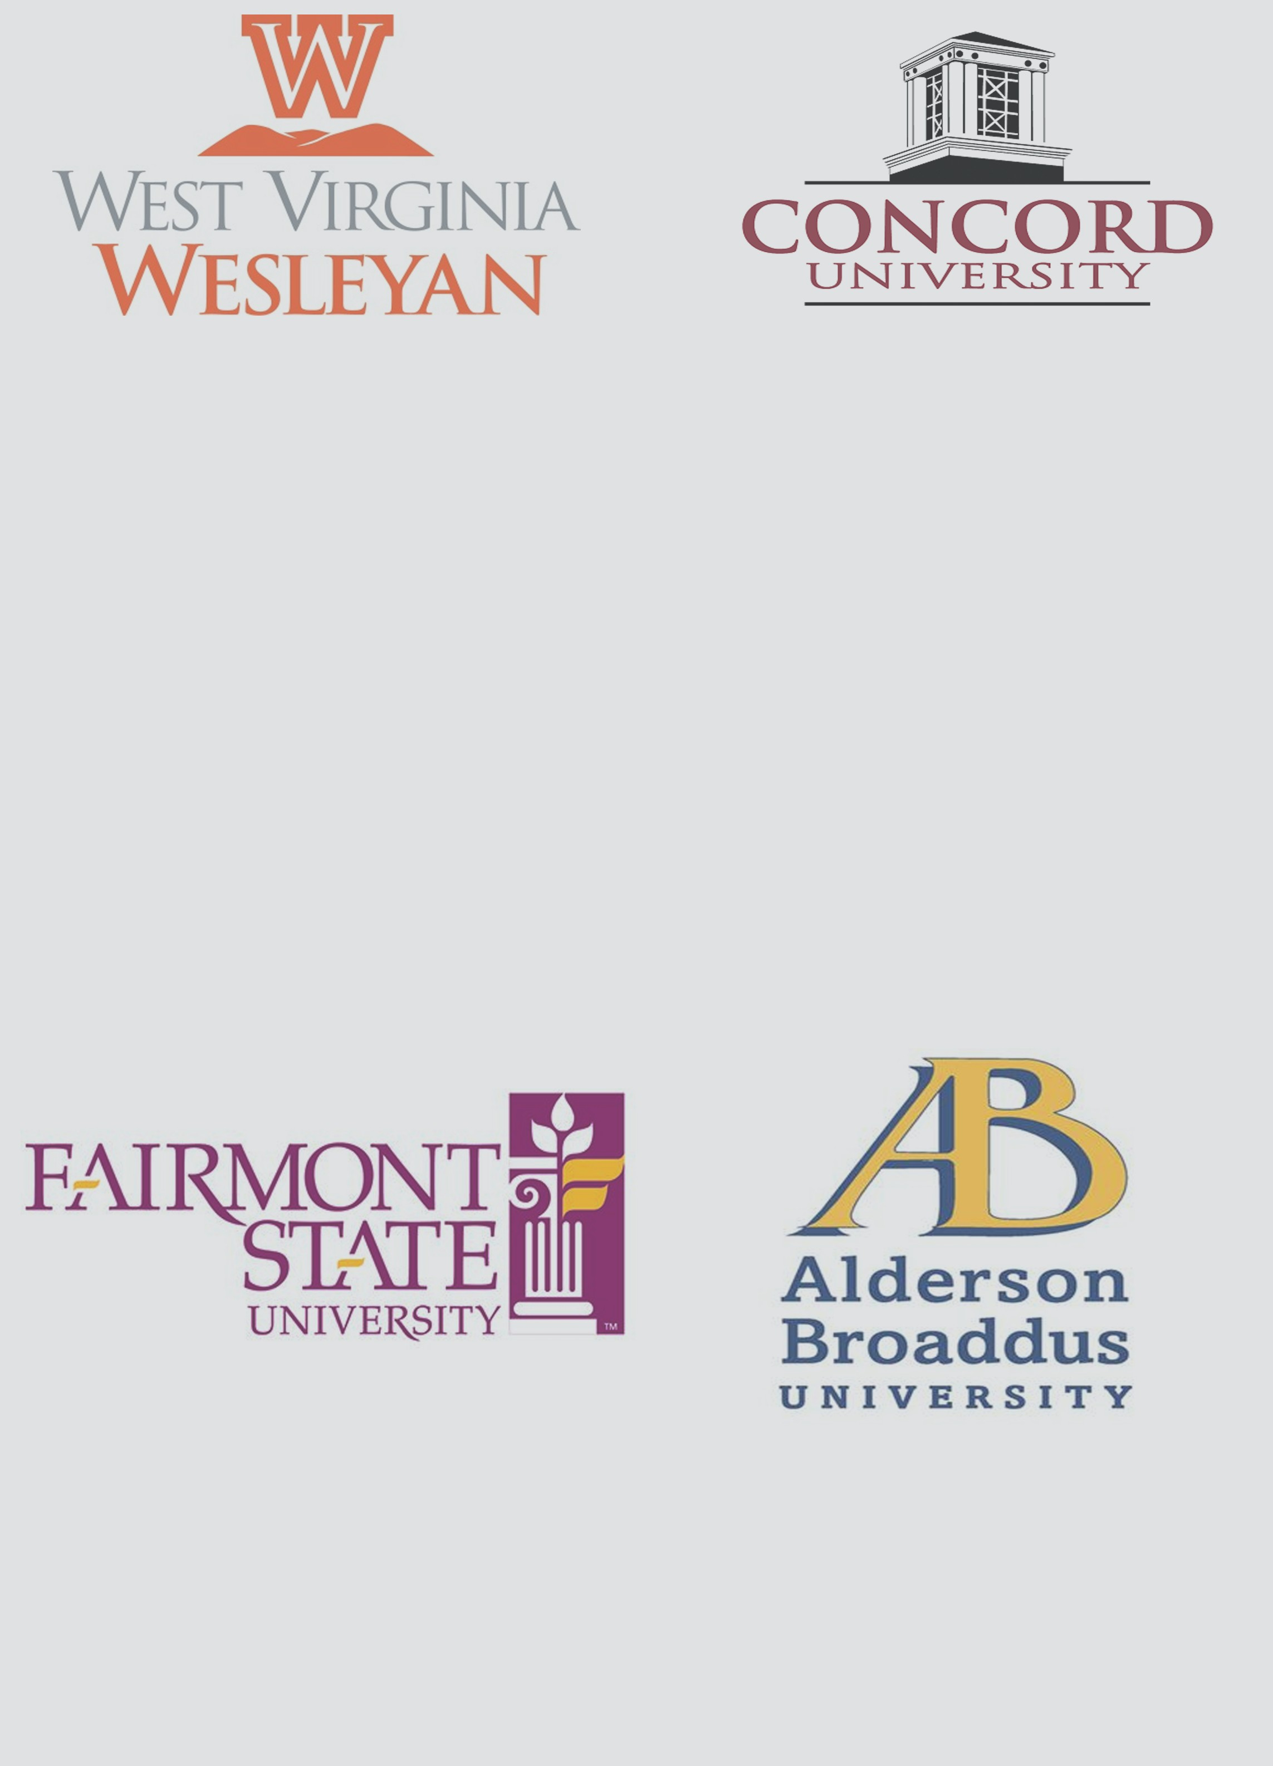Located in Farimont, WV
- 85 majors and 36 minors
- In-state tution: $7,296
- www.fairmontstate.edu
- Located in Philippi, WV
- 28 majors and 34 minors
- In-state tuition: $26,400
- ab.edu

Congrats to all of the seniors who graduated this year. Continue to impress and show what you are made of.

*Little Sneak Peek to the Summer Program

Everyone have a fun and safe summer!!!

REMEMBER

